AI-BASED AUTOMATED EVALUATION OF HANDWRITTEN ANSWER SCRIPTS USING OCR AND SEMANTIC SIMILARITY

CAPSTONE PROJECT REPORT

Submitted by

PAVITHIRA.S– 99220041303
SABANA FATHIMA.A-99220041341
POOJA SRI M.G-99220041318
NASREEN SAJILA U.M-99220040948
in partial fulfillment for the award of the degree
of
BACHELOR OF TECHNOLOGY
IN

COMPUTER SCIENCE AND ENGINEERING



SCHOOL OF COMPUTING
COMPUTER SCIENCE AND ENGINEERING
KALASALINGAM ACADEMY OF RESEARCH
AND EDUCATION
KRISHNANKOIL 626 126

April 2026

DECLARATION

We affirm that the project work titled “AI-Based Automated Evaluation of Handwritten Answer Scripts Using OCR and Semantic Similarity” being submitted in partial fulfilment for the award of the degree of Bachelor of Technology in Computer Science and Engineering is the original work carried out by us. It has not formed part of any other project work submitted for the award of any degree or diploma, either in this or any other University.
Pavithira. S
99220041303
Sabana Fathima. A
99220041341
Pooja Sri M.G
99220041318
Nasreen Sajila U.M
99220040948

This is to certify that the above statement made by the candidate is correct to the best of my knowledge.
Date:

Signature of supervisor
Aravind Chandran
Associate Professor
Department of Computer Science and Engineering



BONAFIDE CERTIFICATE

Certified that this project report “AI-Based Automated Evaluation of Handwritten Answer Scripts Using OCR and Semantic Similarity” is the bonafide work of “Pavithira.s (99220041303), Sabana Fathima.A (99220041341),Pooja Sri M.G(99220041318),Nasreen Sajila(99220040948)” who carried out the project work under my supervision.

Aravind Chandran | Dr. R.Raja Subramanian
SUPERVISOR | HEAD OF THE DEPARTMENT
Associate Professor | Associate Professor & Head
Computer Science and Engineering | Computer Science and Engineering
Kalasalingam Academy of Research  and Education | Kalasalingam Academy of Research  and Education
Krishnankoil 626126 | Krishnankoil 626126
Virudhunagar District. | Virudhunagar District.

Submitted for the Project Viva-voce examination held on

Internal Examiner External Examiner

ACKNOWLEDGEMENT

We would like to begin by expressing our heartfelt gratitude to the Supreme Power for the immense grace that enabled us to complete this project.
We are deeply grateful to the late "Kalvivallal" Thiru T. Kalasalingam, Chairman of the Kalasalingam Group of Institutions, and to "Illayavallal" Dr. K. Sridharan, Chancellor, as well as Dr. S. Shasi Anand, Vice President, who has been a guiding light in all our university’s endeavours.
Our sincere thanks go to our Vice Chancellor, Dr. S. Narayanan, for his inspiring leadership, guidance, and for instilling in us the strength and enthusiasm to work towards our goals.
We would like to express our sincere appreciation to Dr. P. Deepa Lakshmi, Professor & Dean-(SoC), Director Accreditation & Ranking, for her valuable guidance. Our heartfelt gratitude also goes to our esteemed Head of Department, Dr. R.Raja Subramanian, whose unwavering support has been crucial to the successful advancement of our project.
We are especially thankful to our Project Supervisor, Aravind Chandran, for his patience, motivation, enthusiasm, and vast knowledge, which greatly supported us throughout this work.
Our sincere gratitude also goes to Dr.T.Manikumar and Mr.N.R.Sathiskumar Overall Project Coordinators, for their constant encouragement and support in completing this Capstone Project.
Finally, we would like to thank our parents, faculty, non-teaching staff, and friends for their unwavering moral support throughout this journey.


SCHOOL OF COMPUTING
COMPUTER SCIENCE AND ENGINEERING
PROJECT SUMMARY
Project Title | AI-Based Automated Evaluation of Handwritten Answer Scripts Using OCR and Semantic Similarity
Project Team Members (Name with Register No) | Pavithira.S-99220041303  Sabana Fathima.A-99220041341  Pooja Sri M.G-99220041318  Nasreen Sajila-99220040948
Guide Name/Designation | Aravind Chandran, Associate Professor, Department of Computer Science and Engineering
Program Concentration Area | Artificial Intelligence ,Natural Language Processing,OCR,Machine Learning
Technical Requirements | Python, Flask, Azure Computer Vision API, spaCy, NLTK, Transformers (BERT), Scikit-learn, HTML/CSS for frontend
Engineering standards and realistic constraints in these areas
Area | Codes & Standards / Realistic Constraints | Tick ✓
Economic | Reduces manual evaluation costs and saves time. Cloud services may involve minimal operational expenses. | ✓
Environmental | Minimizes paper usage through digital evaluation. Slight energy consumption due to computing resources. | ✓
Social | Provides faster and unbiased evaluation for students.  Improves learning through quick feedback. | ✓
Ethical | Ensures fairness by reducing human bias in grading.  Maintains data privacy and responsible usage. | ✓
Manufacturability | Easy to develop using existing technologies. No physical production or manufacturing required. | ✓
Sustainability | Promotes digital transformation in education. Supports long-term efficient and eco-friendly evaluation. | ✓

Realistic Constraints
Economic Constraint:
The economic feasibility of the proposed system is an important consideration, as it aims to reduce the cost associated with manual evaluation while maintaining high accuracy. The system leverages open-source tools and widely available technologies to minimize development and deployment expenses. However, certain components such as cloud-based OCR services and computational resources may incur operational costs. Therefore, the system is designed to balance performance and cost-effectiveness, ensuring affordability for educational institutions.
Environmental Constraint:
The system contributes positively to environmental sustainability by reducing dependency on paper-based evaluation processes. By enabling digital processing and automated assessment of answer scripts, it minimizes the need for physical storage and paper handling. However, the use of computational resources and cloud infrastructure may lead to energy consumption, which must be managed efficiently to reduce environmental impact.
Social Constraint:
The proposed system has significant social implications as it enhances fairness and consistency in the evaluation process. By reducing human bias and subjectivity, it promotes equal opportunities for students. Additionally, the system provides faster feedback, which supports improved learning outcomes. However, user acceptance among educators may vary, and proper training and awareness are necessary to ensure effective adoption.
Ethical Constraint:
Ethical considerations play a crucial role in the design and implementation of the system. The system must ensure fairness, transparency, and unbiased evaluation of student answers. It is important to maintain data privacy and confidentiality while handling sensitive student information. The system is designed to assist educators rather than replace human judgment, thereby ensuring responsible and ethical use of AI technologies.
Manufacturability Constraint:
As a software-based system, manufacturability is not a major limitation; however, practical implementation and deployment must be considered. The system is designed using standard technologies and modular components, making it easy to develop, deploy, and maintain. The use of existing frameworks and tools ensures that the system can be implemented without complex infrastructure requirements.
Sustainability Constraint:
The system supports long-term sustainability by promoting digital transformation in the education sector. It reduces reliance on manual processes and enables efficient utilization of technological resources. The modular and scalable design allows future enhancements and adaptability to evolving requirements. Continuous improvements in AI and OCR technologies can further enhance the system’s sustainability and long-term usability.

ABSTRACT
The there is a strong need for intelligent and scalable automated evaluation systems. Existing automated grading approaches largely rely on keyword-based matching techniques, which fail to capture the semantic meaning of student answers and may result in unfair evaluation when correct concepts are expressed using different wording.
This project presents an AI-based automated evaluation system for handwritten descriptive answer scripts using Optical Character Recognition (OCR) and semantic similarity analysis. The proposed system converts handwritten answer scripts into machine-readable text through image preprocessing and OCR techniques. The extracted text is then normalized using Natural Language Processing methods such as tokenization, stopword removal, and lemmatization. To evaluate answers based on meaning rather than exact word matching, transformer-based semantic embeddings are generated for both student answers and reference answers, and cosine similarity is used to measure conceptual alignment.
The system produces objective similarity scores that reflect the semantic correctness of student responses and supports consistent and unbiased evaluation. Experimental results demonstrate that the proposed approach significantly reduces evaluation time while maintaining strong alignment with human grading for well-written and moderately legible answers. The system also improves grading consistency and scalability, making it suitable for large-scale academic assessments. Although challenges such as poor handwriting recognition and non-textual answer evaluation remain, the proposed system provides a practical and effective solution for automated descriptive answer evaluation. This work highlights the potential of Artificial Intelligence in enhancing fairness, efficiency, and reliability in educational assessment systems.
evaluation of handwritten descriptive answer scripts is a fundamental yet challenging task in academic assessment. Traditional manual evaluation methods are time-consuming, labor-intensive, and often affected by evaluator fatigue, subjectivity, and inconsistency. With the increasing number of students and the growing demand for timely and fair assessment.
Keywords
Artificial Intelligence, Automated Answer Evaluation, Handwritten Answer Scripts, Optical Character Recognition, Natural Language Processing; Semantic Similarity, Transformer-Based Models, Sentence Embeddings, Meaning-Based Grading; AI in Education

TABLE OF CONTENTS
TITLE |  | PAGE NO.
ABSTRACT |  | VII
LIST OF TABLES |  | X
LIST OF FIGURES |  | X
LIST OF ACADEMIC REFERENCE COURSES |  | XI
CHAPTER I | INTRODUCTION | 1
1.1 | Background and Motivation
1.2 | Problem Statement
1.3 | Objectives of the Project
1.4 | Scope of the Project
1.5 | Methodology Overview
1.6 | Organization of the Report
CHAPTER II | LITERATURE REVIEW | 8
2.1 | Overview of Related Work | 8
2.2 | Review of Similar Projects or Research Papers | 9
2.3 | Summary and Gap Identification | 10
CHAPTER III | SYSTEM ANALYSIS | 12
3.1 | Requirements Gathering | 12
3.2 | Functional Requirements | 13
3.3 | Non-Functional Requirements | 14
3.4 | Feasibility Study  - Technical Feasibility  - Operational Feasibility  - Economic Feasibility | 14
3.5 | Risk Analysis | 15
CHAPTER IV | SYSTEM DESIGN | 16
4.1 | Overall System Architecture | 16
4.2 | Module Design | 17
4.3 | Data flow design | 18
4.4 | User Interface Design | 19
CHAPTER V | IMPLEMENTATION | 21
5.1 | Technology Stack | 21
5.2 | Implementation of Modules  5.2.1 Module 1  5.2.2 Module 2  5.2.3 Module 3 | 22
5.3 | Integration of Modules | 25
CHAPTER VI | TESTING | 26
6.1 | Testing Methodology  6.1.1 Unit Testing  6.1.2 Integration Testing  6.1.3 System Testing  6.1.4 User Acceptance Testing (UAT) | 26
6.2 | Test Cases and Results | 30
6.3 | Bug Tracking and Resolution | 31
CHAPTER VII | RESULTS AND DISCUSSION | 34
7.1 | Experimental setup and Dataset description | 34
7.2 | Evaluation Metrics | 34
7.3 | Comparison with Existing Systems | 39
7.4 | Challenges Faced | 39
7.5 | Solutions and Improvements | 40
7.6 | Discussions and Results | 41
7.7 | Limitation and observations | 41
CHAPTER VIII | CONCLUSION & FUTURE SCOPE | 42
8.1 | Conclusion | 42
8.2 | Future Scope | 43
8.3 | Project Contribution and Impact | 44
REFERENCES : List of books, articles, research papers, and other resources used |  | 46
PUBLICATION
CERTIFICATIONS
PLAGIARISM REPORT

LIST OF TABLES

TABLES | DETAILS | PAGE NO.
Table 1 | Semantic Similarity score interpretation | 24
Table 2 | Testing and validation | 27
Table 3 | Test cases and results | 30
Table 4 | Ablation study | 37

LIST OF FIGURES
FIGURES | DETAILS | PAGE NO.
Figure 1 | User Interface of Ai powered answer sheet evaluation system | 2
Figure 2 | Architecture Diagram | 17
Figure 3 | Internal processing and evaluation pipeline | 18
Figure 4 | Full mode evaluation | 34
Figure 5 | SBERT model confusion matrix | 35
Figure 6 | NLI model confusion matrix | 35
Figure 7 | Logic flow model confusion matrix | 36

LIST OF ACADEMIC REFERENCE COURSES
S. NO. | COURSE CODE | COURSE NAME
1 | 21CSE1402 | Python Programming
2 | 213CSE1301 | Introduction to Artificial Intelligence and Machine Learning
3 | 212CSE2304 | Machine Learning
4 | 213CSE3303 | Natural Language Processing
5 | 213CSE3301 | Deep Learning

CHAPTER – I
INTRODUCTION
  - Background and Motivation
Assessment plays a critical role in the education system, as it serves as the primary mechanism for evaluating students’ understanding, analytical ability, and depth of knowledge. Among various assessment formats, descriptive and long-answer questions are widely adopted in schools, colleges, and universities because they encourage conceptual thinking, structured reasoning, and subject comprehension. Unlike objective questions, descriptive answers allow students to express ideas in their own words, making them an effective tool for measuring higher-order cognitive skills. However, evaluating such answers has remained largely manual, especially when responses are handwritten.
Manual evaluation of handwritten answer scripts is a demanding and resource-intensive task. Educators are required to read, interpret, and assess each answer carefully, often under strict time constraints. In large academic institutions, examinations may involve hundreds or even thousands of answer scripts, making the evaluation process lengthy and exhausting. Factors such as evaluator fatigue, pressure to complete evaluations within deadlines, and variability in handwriting styles can significantly affect grading consistency.
Even when a standardized evaluation rubric is followed, subjective judgment and human limitations may lead to variations in scores for similar answers.Another major concern associated with manual grading is evaluator bias and inconsistency. Different evaluators may interpret the same answer differently, resulting in unequal scoring. Even the same evaluator may assign varying scores to similar answers when assessed at different times. Such inconsistencies can impact the fairness and reliability of assessment outcomes, leading to dissatisfaction among students and challenges in maintaining academic integrity. These issues become more prominent as student enrollment increases and educational systems scale up.
With the rapid digital transformation of education, there is an increasing demand for efficient, scalable, and technology-driven assessment solutions. Online learning platforms, digital classrooms, and remote examinations have highlighted the need for faster evaluation mechanisms that can provide timely feedback to students. Traditional automated grading systems have attempted to address this need, but most of them are limited to objective questions or rely on keyword-based matching for descriptive answers. Keyword-based approaches often fail to capture conceptual correctness, as students may use different vocabulary or sentence structures to express the same idea.
Recent advancements in Artificial Intelligence (AI) have opened new possibilities for intelligent assessment systems. Natural Language Processing (NLP) techniques enable machines to understand linguistic patterns, contextual meaning, and semantic relationships between words and sentences. At the same time, Computer Vision technologies such as Optical Character Recognition (OCR) have made it possible to convert handwritten text into machine-readable form. Transformer-based models further enhance these capabilities by learning deep contextual representations of text, allowing systems to move beyond surface-level matching.
By integrating OCR with semantic similarity analysis, automated evaluation systems can assess handwritten descriptive answers based on meaning rather than exact wording. Such systems can significantly reduce evaluation time, improve consistency, and support unbiased grading practices. This project is motivated by the need to leverage these emerging technologies to design an automated evaluation framework that assists educators, enhances assessment efficiency, and maintains fairness in grading while preserving the essential role of human oversight.
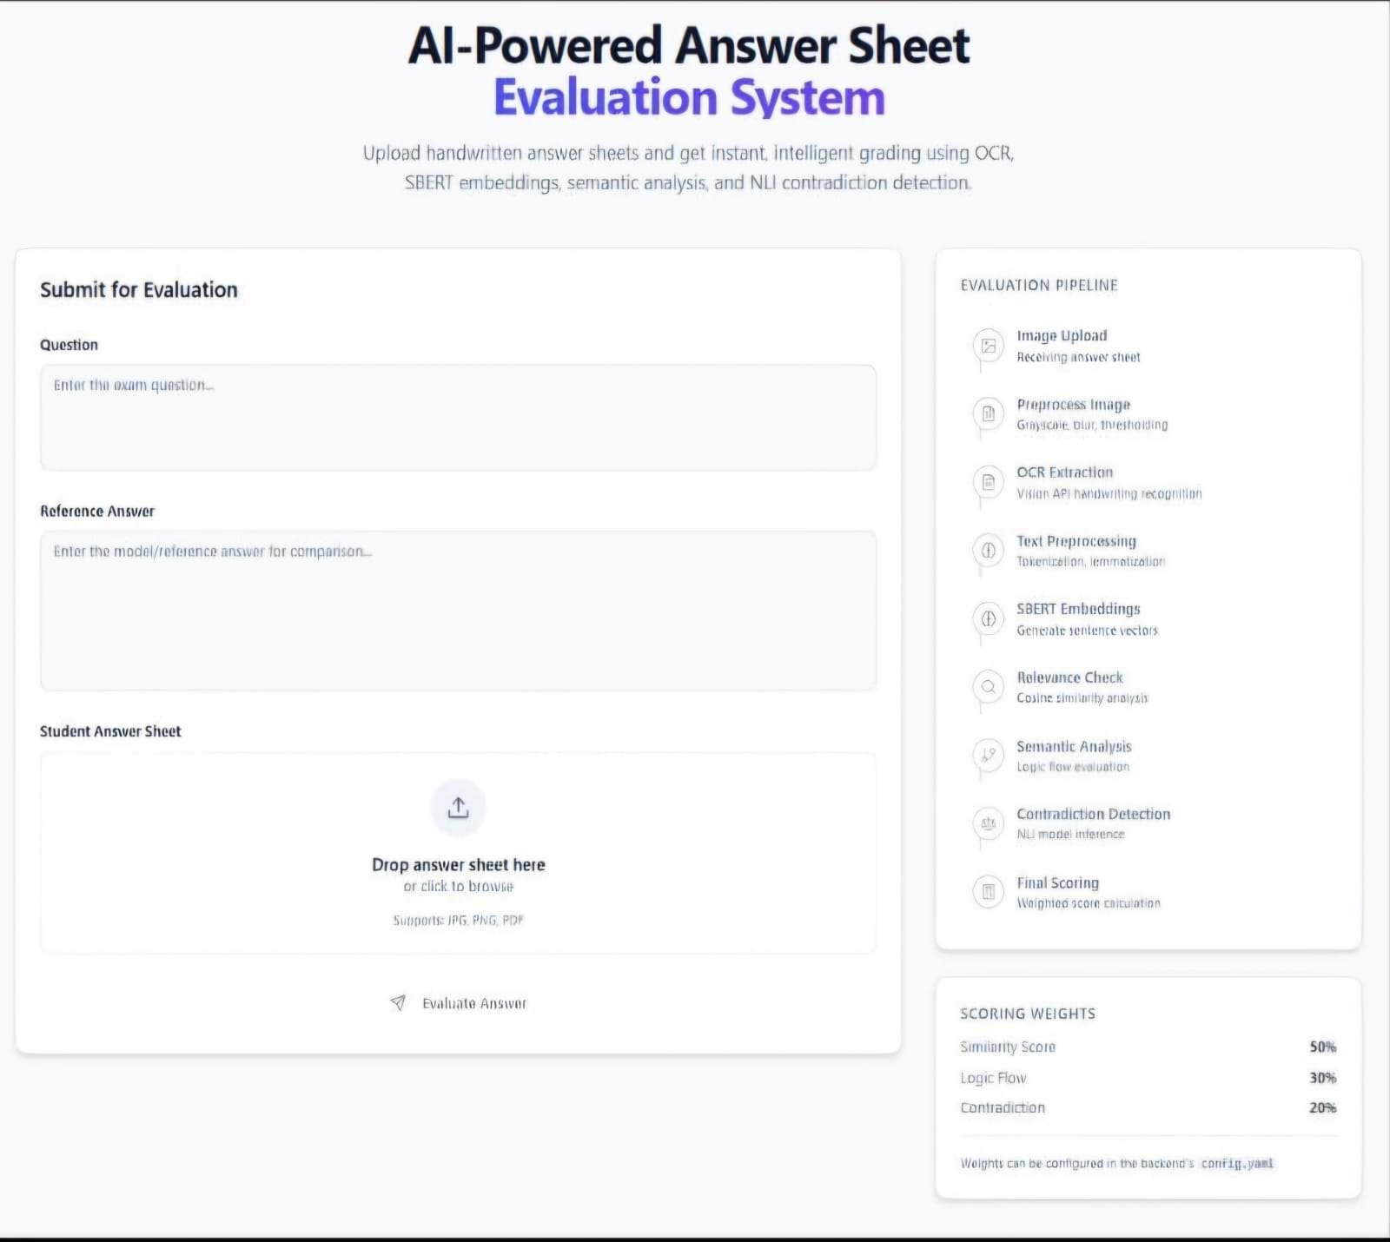
Fig 1:User Interface of AI-Powered Answer Sheet Evaluation System
  - Problem Statement
The evaluation of handwritten descriptive answer scripts remains one of the most challenging aspects of academic assessment. Despite technological advancements in education, most institutions continue to rely on manual grading methods for descriptive answers. This approach is inherently time-consuming and places a heavy workload on educators, particularly during large-scale examinations. The process is also prone to human errors, subjectivity, and inconsistencies, which can compromise the accuracy and fairness of assessment results.
One of the primary challenges in manual evaluation is variability in handwriting styles. Students exhibit significant differences in handwriting clarity, spacing, and formatting, making it difficult for evaluators to interpret responses consistently. Poor handwriting may unintentionally affect scores even when the content is conceptually correct. Additionally, evaluators may experience fatigue after reviewing large volumes of answer scripts, leading to reduced attention and inconsistent scoring patterns.
Existing automated grading solutions attempt to reduce manual effort, but most of them rely on keyword-based or rule-based techniques. These systems compare student answers with predefined keywords or phrases and assign scores based on word overlap. While such approaches are simple to implement, they fail to recognize semantic equivalence. Students who express correct concepts using alternative wording may receive lower scores, whereas answers containing keywords but lacking conceptual clarity may score higher. This limitation makes keyword-based systems unsuitable for meaningful evaluation of descriptive answers.
Another significant challenge lies in handling handwritten answers. Converting handwritten text into digital form is not trivial due to variations in handwriting styles, image quality, lighting conditions, and noise in scanned documents. Conventional OCR systems often struggle with handwritten content, resulting in recognition errors that further degrade evaluation accuracy. Without robust text extraction and preprocessing mechanisms, automated grading systems cannot reliably assess handwritten answers.
The absence of semantic understanding in traditional automated systems highlights the need for a more intelligent approach. An effective evaluation system must not only extract text accurately from handwritten scripts but also understand the contextual meaning of student responses. It should be capable of comparing student answers with reference answers at a conceptual level, rather than relying solely on exact word matches.
Therefore, the core problem addressed in this project is the lack of an automated evaluation system that can accurately and fairly assess handwritten descriptive answer scripts by combining robust OCR techniques with semantic similarity analysis. The system must handle handwriting variability, reduce subjectivity, and provide consistent evaluation outcomes while remaining scalable and practical for academic environments.
  - Objectives of the Project
The primary objective of this project is to develop an Artificial Intelligence–based automated evaluation system for handwritten descriptive answer scripts that ensures fair, consistent, and meaningful assessment. The system is designed to overcome the limitations of manual grading and traditional keyword-based automated evaluation methods by incorporating semantic understanding into the grading process.
One of the key objectives is to accurately extract handwritten text from answer scripts using Optical Character Recognition techniques. Since handwritten answers pose unique challenges compared to printed text, the system aims to improve recognition accuracy through preprocessing and robust OCR integration. This step forms the foundation of the automated evaluation pipeline.
Another important objective is to preprocess and normalize the extracted text using Natural Language Processing techniques. Text normalization helps reduce noise caused by OCR errors, variations in word forms, and linguistic inconsistencies. By applying techniques such as tokenization, stopword removal, and lemmatization, the system prepares clean and standardized textual data for semantic analysis.
A central objective of the project is to evaluate student answers based on semantic similarity rather than keyword matching. The system aims to capture the conceptual alignment between student responses and reference answers, even when different vocabulary or sentence structures are used. This ensures that students are evaluated fairly based on understanding rather than memorization or exact phrasing.
The project also aims to reduce the overall evaluation time required for descriptive answer scripts. By automating the evaluation process, educators can significantly decrease manual workload and focus on higher-level academic responsibilities such as feedback, mentoring, and curriculum improvement. The system is designed to support scalability, making it suitable for institutions with large student populations.
Another objective is to provide objective and consistent evaluation outcomes. By minimizing human subjectivity, the system aims to improve grading reliability and ensure uniform assessment standards across different evaluators and examination sessions. Additionally, the system seeks to generate interpretable similarity scores that can assist educators in understanding evaluation results.
Overall, the project aims to design a supportive evaluation tool that enhances efficiency, fairness, and transparency in academic assessment while complementing the role of educators rather than replacing human judgment.
1.4 Scope of the Project
The scope of this project is focused on the automated evaluation of handwritten and printed descriptive answers in academic assessment scenarios. The system is designed to support educational institutions such as schools, colleges, and universities where descriptive answers are commonly used to evaluate conceptual understanding.
The project primarily focuses on answers written in the English language and evaluates them by comparing student responses with predefined reference answers. The system assesses answers based on semantic similarity, enabling meaning-based grading rather than surface-level keyword matching. This approach ensures fair evaluation even when students use diverse expressions to convey correct concepts.
The proposed system is intended to function as an assistive tool for educators. It does not aim to completely replace human evaluators but rather to reduce manual workload and improve consistency in grading. Educators may use the system’s evaluation results as a preliminary assessment or decision-support mechanism during grading.
The current scope does not include the evaluation of diagrams, mathematical equations, chemical formulas, or graphical content. Multilingual answer evaluation and subject-specific symbolic reasoning are also outside the present scope. Additionally, the system does not perform plagiarism detection or behavioral analysis of students.
Despite these limitations, the project provides a strong foundation for future enhancements. The modular design allows for extension to multilingual support, diagram evaluation, and integration with learning management systems. Within its defined scope, the system aims to deliver reliable, scalable, and practical automated evaluation for descriptive answers.
1.5 Methodology Overview
The proposed system aims to automate the evaluation of student answer sheets by using Artificial Intelligence and Natural Language Processing techniques. The system compares the student’s answer with a predefined reference answer and determines how closely the meanings of both answers match. This approach reduces the effort required for manual grading and provides faster and more consistent evaluation results.
The methodology begins when a user uploads an image of a student answer sheet through the system interface along with the corresponding question and reference answer. The uploaded image is first processed using image preprocessing techniques such as grayscale conversion, Gaussian blur, and adaptive thresholding to enhance the image quality and improve text recognition accuracy.After preprocessing, Optical Character Recognition (OCR) is applied to extract textual content from the answer sheet. The system primarily uses the Azure Computer Vision API to recognize both printed and handwritten text. In cases where the cloud-based service is unavailable, a fallback OCR model called TrOCR is used locally to ensure reliable text extraction.
The extracted text is then cleaned and prepared for analysis using natural language preprocessing techniques. These techniques include removing special characters, tokenizing the text into words, eliminating stopwords, and applying lemmatization to convert words into their base forms. This preprocessing step helps reduce noise and standardize the text for accurate semantic analysis.Once the text is cleaned, both the student answer and the reference answer are converted into numerical vector representations using the Sentence-BERT (SBERT) model, specifically the all-MiniLM-L6-v2 model. These embeddings capture the semantic meaning of the sentences rather than relying solely on exact word matching.
Finally, the similarity between the two embeddings is calculated using cosine similarity. The similarity score ranges between 0 and 1, where higher values indicate greater similarity between the answers. Based on this score, the system classifies the student’s answer into different evaluation levels such as Excellent, Good, Moderate, or Low match. The final output includes the extracted text from the answer sheet, the similarity score, and the evaluation result displayed to the user.
1.6 Organization of the Report
This report is systematically organized into several chapters to provide a clear and comprehensive understanding of the design, development, and implementation of the proposed AI-based answer script evaluation system. Each chapter focuses on a specific phase of the project, starting from the introduction of the problem to the final evaluation and future enhancements. The structure of the report ensures a logical flow of information, enabling readers to easily understand the concepts, methodologies, and outcomes of the system.
Chapter I –Introduction(current):
This chapter introduces the background and motivation behind the development of the proposed system. It highlights the growing need for automated evaluation systems in modern educational environments, where manual grading is often time-consuming and prone to inconsistencies. The limitations of traditional evaluation methods are discussed, emphasizing issues such as subjectivity and lack of scalability. This chapter also presents the problem statement, clearly defining the challenges addressed by the system. Furthermore, it outlines the objectives, scope of the project, and provides an overview of the methodology adopted to develop the AI-based evaluation system.
Chapter II – Literature Review:
This chapter provides a detailed review of existing research works and technologies related to automated answer evaluation systems. It covers various approaches such as Optical Character Recognition (OCR), Natural Language Processing (NLP), and semantic similarity techniques used in previous studies. The chapter critically analyzes different models and methodologies, highlighting their strengths and limitations. It also discusses key research papers relevant to the project and identifies the research gap, which forms the basis for the proposed system.
Chapter III – System Analysis:
This chapter focuses on analyzing the requirements and feasibility of the proposed system. It includes requirement gathering, functional requirements, and non-functional requirements necessary for system development. The chapter also presents feasibility analysis, including technical, operational, and economic feasibility, to ensure that the system can be effectively implemented in real-world scenarios. This analysis helps in defining the system constraints and ensuring practical applicability.
Chapter IV – System Design:
This chapter describes the overall architecture and design of the system. It explains how different components of the system are structured and interact with each other. The chapter includes detailed descriptions of system architecture, module design, database design, and user interface design. It also illustrates the workflow of the system, showing how input answer sheets are processed and evaluated using AI techniques.
Chapter V – Implementation:
This chapter explains the practical implementation of the proposed system. It describes the tools, technologies, and programming languages used in development. The implementation of various modules such as image preprocessing, OCR-based text extraction, text preprocessing, semantic embedding generation, and similarity computation is discussed in detail. The integration of backend and frontend components is also explained, demonstrating how the complete system functions as a unified application.
Chapter VI – Testing:
This chapter presents the testing strategies used to validate the performance and reliability of the system. It includes different types of testing such as unit testing, integration testing, system testing, and user acceptance testing. The chapter also provides details of test cases, expected outputs, and actual results to ensure that the system meets the specified requirements. Testing results help in identifying errors and improving system performance.
Chapter VII – Results and Discussion:
This chapter presents the outcomes of the implemented system and evaluates its performance. It includes screenshots of the system interface, sample outputs, and evaluation results. The performance of the system is analyzed using appropriate metrics such as accuracy and similarity scores. The chapter also compares the proposed system with existing approaches and discusses challenges faced during development along with possible solutions.
Chapter VIII – Conclusion and Future Scope:
This chapter summarizes the overall work carried out in the project and highlights the key achievements of the proposed system. It reflects on how the objectives of the project have been successfully achieved. The chapter also discusses limitations of the current system and suggests possible future enhancements, such as improving OCR accuracy, supporting multiple languages, and integrating advanced AI models to further enhance evaluation performance.

CHAPTER-II
LITERATURE REVIEW
2.1 Overview of Related Work
The field of automated assessment and answer evaluation has evolved significantly over the past few decades, driven by advancements in Artificial Intelligence, Natural Language Processing, and Computer Vision. Early research in automated grading primarily focused on objective-type questions such as multiple-choice and fill-in-the-blank formats, where evaluation could be performed using simple rule-based or exact matching techniques. While these approaches proved effective for objective assessments, they were inadequate for descriptive answers that require understanding of context, reasoning, and conceptual correctness.
Initial attempts to automate descriptive answer evaluation relied heavily on keyword-based and statistical text analysis methods. Techniques such as term frequency, inverse document frequency (TF-IDF), and bag-of-words models were widely used to compare student responses with reference answers. These methods measured similarity based on word overlap and frequency patterns. Although computationally efficient, they lacked semantic understanding and often failed to recognize correct answers expressed using different vocabulary or sentence structures. As a result, such systems were criticized for unfair scoring and limited reliability in real-world educational settings.
With the advancement of Natural Language Processing, researchers began exploring syntactic and semantic analysis techniques to improve evaluation accuracy. Latent Semantic Analysis (LSA) and Latent Dirichlet Allocation (LDA) were introduced to capture latent semantic relationships between words and documents. These approaches represented text in reduced-dimensional semantic spaces, enabling better comparison of meaning rather than exact word matching. While these models showed improvement over basic keyword-based methods, they still struggled with complex sentence structures, contextual nuances, and domain-specific terminology.
Parallel to developments in NLP, Optical Character Recognition emerged as a crucial technology for handling handwritten answer scripts. Traditional OCR systems were primarily designed for printed text and performed poorly on handwritten inputs due to variations in writing styles, spacing, and character shapes. Research in handwriting recognition focused on feature extraction, pattern recognition, and machine learning-based classifiers to improve accuracy. Despite progress, handwritten OCR remained a challenging problem, particularly in unconstrained academic settings where handwriting quality varies significantly among students.
The introduction of deep learning marked a major turning point in both OCR and NLP research. Convolutional Neural Networks (CNNs) and Recurrent Neural Networks (RNNs) improved handwriting recognition by learning visual patterns directly from data. In parallel, word embeddings such as Word2Vec and GloVe enabled distributed representations of words, capturing semantic relationships more effectively than traditional models. These embeddings allowed automated grading systems to move closer to meaning-based evaluation.
More recently, transformer-based models have revolutionized NLP by enabling deep contextual understanding of text. Models such as BERT and its variants generate context-aware embeddings that capture sentence-level meaning. When combined with similarity measures such as cosine similarity, these models allow systems to evaluate how closely a student’s answer aligns with a reference answer at a conceptual level. This shift from surface-level matching to semantic similarity has significantly improved the potential accuracy and fairness of automated descriptive answer evaluation.
Overall, related work demonstrates a clear progression from simple keyword matching to sophisticated semantic analysis. However, challenges remain in integrating robust OCR with semantic evaluation in a unified framework, particularly for handwritten answer scripts. This project builds upon these advancements by combining OCR and transformer-based semantic similarity to address the limitations of existing approaches.
2.2 Review of Similar Projects and Research Papers
Several research studies and prototype systems have explored automated evaluation of descriptive answers using Artificial Intelligence techniques. One category of related work focuses on automated essay scoring systems, which assess long-form student responses based on linguistic features, coherence, grammar, and content relevance. These systems often employ machine learning models trained on large datasets of graded essays. While effective for essays, they are less suitable for short descriptive answers typically found in academic examinations, where concise and precise responses are required.
Another group of studies investigates semantic similarity-based grading methods. These approaches compare student answers with model answers using similarity measures derived from word embeddings, sentence embeddings, or latent semantic representations. Research has shown that semantic similarity models outperform keyword-based systems in recognizing paraphrased answers and alternative expressions of correct concepts. However, many of these studies assume that student responses are already available in digital text form, limiting their applicability to handwritten answer scripts.
Some projects have integrated OCR with automated grading, focusing on converting handwritten answers into text before evaluation. Early systems relied on traditional OCR engines, which produced high error rates for handwritten inputs. Recognition errors often propagated through the evaluation pipeline, resulting in inaccurate grading. Recent research has attempted to mitigate this issue by applying preprocessing techniques such as noise reduction, thresholding, and segmentation to improve OCR accuracy. Despite these efforts, handwriting variability remains a major challenge.
Transformer-based models have recently been applied to automated grading with promising results. Sentence-level embeddings generated by models such as Sentence-BERT have demonstrated strong performance in capturing semantic similarity between student answers and reference answers. Studies comparing cosine similarity of embeddings with human evaluation scores report high correlation, indicating that semantic similarity can serve as a reliable proxy for conceptual correctness. However, these studies often focus on small datasets or controlled environments, leaving questions about scalability and robustness unanswered.
In the context of educational assessment, some researchers emphasize the importance of fairness, transparency, and interpretability in automated grading systems. Systems that provide only numerical scores without explanation are often viewed with skepticism by educators and students. As a result, recent work explores the inclusion of qualitative feedback alongside similarity scores to enhance trust and usability.
While these projects contribute valuable insights, several gaps remain. Many systems address either OCR or semantic evaluation in isolation, rather than integrating both effectively. Others lack scalability or fail to account for real-world handwriting variability. This project differentiates itself by proposing an integrated framework that combines robust OCR techniques with transformer-based semantic similarity analysis, specifically targeting handwritten descriptive answer scripts in academic environments.
2.3 Summary and Research Gap Identification
The review of existing literature highlights significant progress in automated assessment technologies, particularly in the areas of Natural Language Processing, Optical Character Recognition, and semantic analysis. Keyword-based and statistical methods laid the foundation for early automated grading systems, but their limitations in handling descriptive answers and semantic equivalence are well documented. Advanced NLP techniques such as LSA, word embeddings, and transformer-based models have substantially improved semantic understanding, enabling more accurate comparison of textual responses.
Despite these advancements, several research gaps remain. One major gap is the lack of integrated systems capable of handling handwritten answer scripts end-to-end. Many studies assume clean digital text input, overlooking the complexities introduced by handwritten responses. OCR errors, handwriting variability, and image quality issues significantly affect evaluation accuracy when not properly addressed.
Another gap lies in the reliance on surface-level similarity measures in some automated grading systems. While transformer-based models offer deep semantic understanding, not all systems fully leverage these capabilities. Some approaches still depend on shallow features or limited training data, reducing their effectiveness in diverse academic contexts.
Scalability and practicality also remain concerns. Many research prototypes are evaluated on small datasets under controlled conditions, making it difficult to assess their performance in real-world educational environments with large student populations. Additionally, limited attention is given to system interpretability and usability from an educator’s perspective.
This project addresses these gaps by proposing an AI-based automated evaluation framework that integrates OCR and semantic similarity analysis in a unified pipeline. By focusing on handwritten descriptive answer scripts, the system tackles a real-world problem that remains underexplored in existing literature. The use of transformer-based semantic embeddings enables meaning-based evaluation, while preprocessing and OCR integration improve robustness against handwriting variability.
In summary, the literature review reveals the need for a comprehensive, scalable, and fair automated evaluation system that bridges the gap between OCR and semantic analysis. The proposed project builds upon existing research while addressing its limitations, contributing a practical solution for automated assessment in academic environments.

CHAPTER III
SYSTEM ANALYSIS
3.1 Requirements Gathering
Requirements gathering is a crucial phase in the development of any software system, as it defines what the system is expected to accomplish and establishes the foundation for design and implementation. For the proposed AI-based automated evaluation system, requirements were gathered by analyzing existing examination practices, understanding the challenges faced by educators during manual evaluation, and studying the limitations of current automated grading systems. The primary stakeholders for this system include educators, academic institutions, examination coordinators, and students.
The requirements gathering process focused on identifying real-world challenges associated with handwritten descriptive answer evaluation. Educators often face difficulties such as large volumes of answer scripts, time pressure, inconsistent grading, and fatigue-induced errors. These factors highlighted the need for an automated system that could assist in preliminary evaluation while maintaining fairness and accuracy. From an institutional perspective, scalability, reliability, and transparency were identified as essential requirements to ensure adoption and trust in the system.
Another key consideration during requirements gathering was the nature of handwritten answer scripts. Handwriting styles vary significantly among students, and answer sheets may include noise, skew, or poor image quality due to scanning or photography. Therefore, the system must be capable of handling diverse input conditions and still produce reliable results. Additionally, educators emphasized that automated evaluation should be meaning-based rather than dependent on exact word matching, as descriptive answers often allow multiple valid expressions of the same concept.
Functional expectations were gathered by studying existing assessment workflows. Typically, evaluators compare student answers with reference answers or marking schemes and assign marks based on conceptual coverage. Translating this process into an automated system required identifying the core evaluation steps: text extraction, normalization, semantic comparison, and score generation. Non-functional requirements such as performance, usability, security, and reliability were also emphasized during this phase.
The system was required to operate within realistic academic constraints, including limited computational resources and ease of deployment. Educators expressed the need for a simple interface that does not require advanced technical knowledge. At the same time, the system must provide outputs that are interpretable and useful for academic decision-making.
In summary, requirements gathering focused on balancing technical feasibility with academic practicality. The outcome of this phase was a comprehensive set of functional and non-functional requirements that guide the system design, ensuring that the proposed solution addresses real educational challenges while remaining scalable and user-friendly.
3.2 Functional Requirements
Functional requirements describe the specific capabilities and behaviors that the automated evaluation system must support. These requirements define how the system processes input, performs evaluation, and generates output. The functional requirements of the proposed system are centered around automating the evaluation of handwritten descriptive answer scripts in a reliable and meaningful manner.
The first major functional requirement is input handling. The system must allow educators or administrators to upload handwritten answer scripts in commonly used formats such as scanned images or document files. Along with the answer script, the system must accept the corresponding reference answer or model solution against which student responses will be evaluated. The system should validate uploaded files to ensure they meet acceptable quality and format standards.
The second functional requirement is text extraction. Once an answer script is uploaded, the system must convert handwritten content into machine-readable text using Optical Character Recognition techniques. This process should be robust enough to handle variations in handwriting style, spacing, and alignment. The extracted text should preserve the logical structure of the answer to the extent possible to support accurate semantic evaluation.
Another important functional requirement is text preprocessing. The system must clean and normalize the extracted text by removing noise, correcting basic inconsistencies, and standardizing linguistic forms. Preprocessing steps such as tokenization, stopword removal, and lemmatization help prepare the text for semantic analysis. This stage ensures that minor variations in word forms do not affect evaluation results.
Semantic comparison is the core functional requirement of the system. The system must compare student answers with reference answers based on semantic similarity rather than keyword overlap. It should generate vector representations of both texts and compute similarity scores that reflect conceptual alignment. The similarity score must be normalized and interpretable to support academic evaluation.
The system must also generate evaluation outputs. These outputs include similarity scores, qualitative assessment indicators, or grading categories that reflect the level of correctness. The results should be displayed in a clear and understandable format to assist educators in decision-making. Additionally, the system should allow repeated evaluations for multiple answer scripts to support batch processing.
Overall, the functional requirements ensure that the system performs all essential evaluation tasks accurately and consistently, transforming handwritten answers into meaningful assessment outcomes.
3.3 Non-Functional Requirements
Non-functional requirements define the quality attributes of the system and determine how well it performs its functions. These requirements are critical for ensuring that the automated evaluation system is reliable, efficient, secure, and user-friendly in real-world academic environments.
Performance is a key non-functional requirement. The system must process answer scripts within a reasonable time frame, even when handling multiple submissions. Delays in evaluation reduce the usefulness of automated grading, particularly in large-scale examinations where timely feedback is essential. Therefore, the system should be optimized to balance accuracy and processing speed.
Scalability is another important requirement. The system must be capable of handling an increasing number of users and answer scripts without significant degradation in performance. Academic institutions may need to evaluate hundreds or thousands of scripts during examination periods, making scalability a critical consideration.
Usability is essential for adoption by educators. The system interface should be intuitive and easy to navigate, requiring minimal technical expertise. Clear instructions, simple workflows, and understandable outputs enhance user confidence and acceptance of the system. The system should support smooth interaction without overwhelming users with technical details. Reliability and availability are also critical non-functional requirements. The system must operate consistently without frequent failures or crashes. Mechanisms for error handling and recovery should be in place to ensure continuous operation. Consistent performance builds trust among users and encourages long-term adoption.
Security and privacy requirements are particularly important in academic contexts. Answer scripts and evaluation results may contain sensitive student information. The system must ensure secure data handling, controlled access, and protection against unauthorized use. Privacy considerations must be addressed to comply with institutional and ethical standards. In summary, non-functional requirements ensure that the system is not only functionally correct but also practical, secure, and dependable in real academic environments.
3.4 Feasibility Study
The feasibility study evaluates whether the proposed automated evaluation system can be successfully developed and deployed within realistic constraints. This study considers technical, operational, and economic feasibility to assess the viability of the project.

3.4.1 Technical Feasibility
From a technical perspective, the proposed system leverages well-established technologies such as Optical Character Recognition, Natural Language Processing, and transformer-based language models. These technologies are supported by mature libraries and frameworks, making technical implementation feasible. The availability of pre-trained models reduces development complexity and enables effective semantic analysis without requiring excessive computational resources.
3.4.2 Operational Feasibility
Operational feasibility focuses on how well the system integrates into existing academic workflows. Since the system is designed as an assistive tool rather than a replacement for human evaluators, it aligns well with current practices. Educators can use the system for preliminary evaluation or consistency checking, making operational adoption practical.
3.4.3 Economic Feasibility
Economic feasibility examines cost considerations. The system primarily relies on software-based components and open-source tools, minimizing development and deployment costs. Institutions can deploy the system using existing infrastructure, making it economically viable for academic environments.
3.5 Risk Analysis
Risk analysis identifies potential challenges that may affect the successful development and deployment of the system. One major risk is OCR accuracy, particularly for poorly written or low-quality handwritten scripts. OCR errors may propagate through the evaluation pipeline, affecting semantic similarity results.

CHAPTER IV
SYSTEM DESIGN
4.1 Overall System Architecture
System architecture defines the high-level structure of the proposed automated evaluation system and illustrates how different components interact to achieve the desired functionality. For an AI-based automated evaluation system, architectural design plays a crucial role in ensuring modularity, scalability, robustness, and ease of future enhancement. The proposed system architecture follows a layered and modular approach, where each component is responsible for a specific function in the evaluation pipeline.
At a high level, the system is composed of five primary layers: the input layer, preprocessing layer, OCR layer, semantic analysis layer, and output layer. This separation of concerns ensures that changes or improvements in one layer do not adversely affect other components. Such an architectural design is particularly important for academic systems that may need to evolve over time.
The input layer serves as the interface between users and the system. It accepts handwritten answer scripts uploaded in the form of scanned images or document files. Along with student answers, the system also receives reference answers or model solutions that serve as the basis for evaluation. This layer is designed to validate input formats and ensure that only acceptable files are processed further.
The preprocessing layer is responsible for preparing raw input data for accurate analysis. Handwritten answer scripts may suffer from issues such as low contrast, background noise, skew, or uneven lighting. To address these challenges, image preprocessing techniques are applied to enhance text visibility and reduce noise. This step significantly improves the accuracy of subsequent OCR operations and ensures reliable text extraction.
The OCR layer converts pre-processed handwritten content into machine-readable text. This layer plays a critical role, as inaccuracies at this stage can propagate through the entire system. The architecture supports robust OCR mechanisms capable of handling diverse handwriting styles. The extracted text is structured logically to preserve sentence flow and contextual relationships.
The semantic analysis layer forms the core intelligence of the system. This layer processes both student answers and reference answers using Natural Language Processing techniques and semantic embedding models. By generating contextual vector representations of text, the system enables meaning-based comparison rather than surface-level keyword matching. This layer ensures that conceptual similarity is accurately captured even when students use varied expressions.
Finally, the output layer presents evaluation results in an interpretable format. This includes similarity scores, qualitative assessment categories, and optional feedback indicators. The architecture ensures that outputs are transparent and usable for educators, enabling informed academic decisions.
Overall, the proposed system architecture emphasizes modularity, scalability, and robustness. By clearly separating functional responsibilities, the architecture supports reliable automated evaluation while allowing future extensions such as multilingual support, diagram evaluation, and learning management system integration.
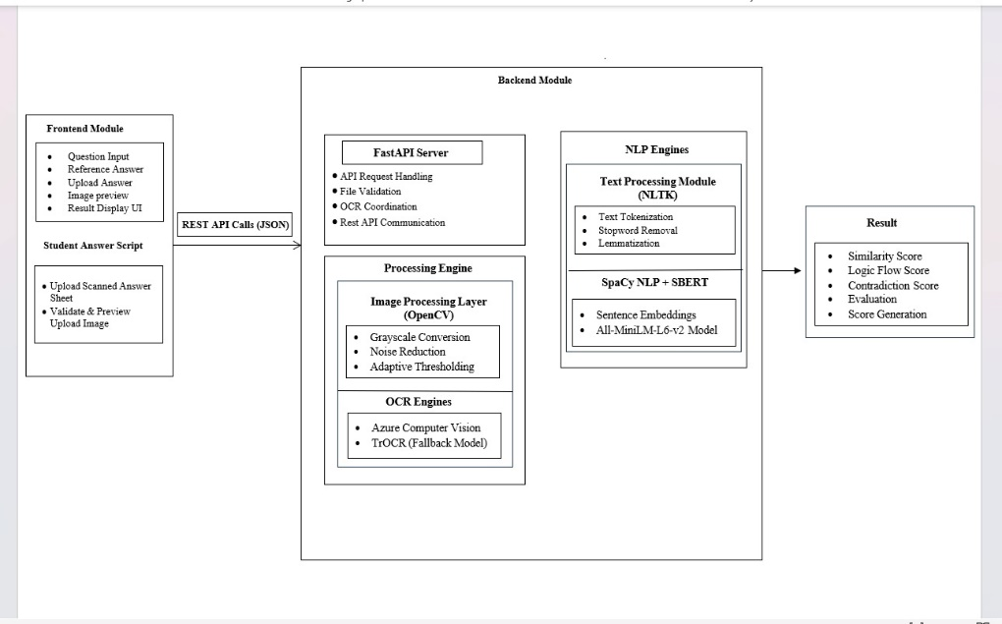
Fig 2: Architecture Diagram
4.2 Module Design
Module design focuses on breaking down the overall system into manageable and logically independent components. Each module is designed to perform a specific function while interacting seamlessly with other modules. This approach simplifies development, testing, and maintenance of the system.
The first major module is the Input Management Module. This module handles the upload and validation of handwritten answer scripts and reference answers. It ensures that files are in supported formats and meet minimum quality requirements. By performing early validation, this module prevents unnecessary processing of invalid inputs and improves system reliability.
The Image Preprocessing Module is responsible for enhancing the quality of uploaded handwritten scripts. It applies techniques such as grayscale conversion, noise reduction, and contrast enhancement to improve text visibility. This module plays a critical role in improving OCR accuracy, particularly for low-quality or poorly scanned documents.
The OCR Module converts processed images into digital text. This module is designed to handle handwriting variability and preserve textual structure. It outputs raw extracted text, which may contain minor recognition errors. The modular design allows the OCR component to be updated or replaced as more advanced recognition models become available.
The Text Preprocessing Module cleans and normalizes extracted text using Natural Language Processing techniques. Operations such as tokenization, stopword removal, and lemmatization reduce linguistic variability and prepare text for semantic comparison. This module ensures that minor grammatical or lexical differences do not affect evaluation outcomes.
The Semantic Similarity Module is the core evaluation component. It generates semantic embeddings for both student answers and reference answers using transformer-based language models. Cosine similarity is computed between embeddings to measure conceptual alignment. This module enables meaning-based grading and addresses the limitations of keyword-based systems.
The Result Generation Module processes similarity scores and maps them to interpretable evaluation outputs. These outputs may include numerical scores, grading categories, or qualitative feedback indicators. The module ensures that results are presented clearly and consistently for academic use.
By decomposing the system into these modules, the design promotes flexibility, maintainability, and scalability. Each module can be independently tested and optimized, ensuring robust overall system performance.

Fig 3:internal processing and evaluation pipeline
4.3 Data Flow Design
Data flow design explains how information moves through the system during the evaluation process. It provides insight into data transformations and dependencies between system components.The data flow begins with the upload of handwritten answer scripts and reference answers. These inputs flow into the preprocessing stage, where images are enhanced and prepared for OCR. The extracted text then flows into the text preprocessing module, where normalization is performed.
Normalized text data flows into the semantic analysis module, where embeddings are generated and similarity scores are computed. The resulting scores flow into the result generation module, which produces evaluation outputs. Clear data flow design ensures efficient processing, minimizes redundancy, and supports reliable system behavior. It also helps identify potential points of failure and enables effective error handling.
4.4 User Interface Design
User interface design plays a crucial role in ensuring that the proposed AI-based answer script evaluation system is user-friendly, efficient, and accessible to educators with varying levels of technical expertise. The primary objective of the interface is to provide a simple and intuitive environment where users can easily upload answer scripts, enter reference answers, and obtain evaluation results without requiring advanced technical knowledge. The design focuses on minimizing complexity while maximizing usability and functionality.
The interface is structured in a clear and organized manner, allowing users to navigate through different functionalities seamlessly. Key user interface elements include input fields for entering questions and reference answers, file upload components for submitting student answer sheets, and evaluation controls that trigger the automated grading process. The system also provides a well-structured output display, presenting similarity scores, evaluation metrics, and overall grading results in a clear and interpretable format. Visual elements such as labels, icons, and section divisions are used to enhance readability and improve user interaction.Special attention is given to ensuring clarity and transparency in system outputs. Since the system performs automated evaluation using AI techniques such as OCR and semantic similarity analysis, it is important that users understand how the results are generated. Therefore, the interface is designed to present results in an understandable manner, including breakdowns of scoring components such as similarity score, logical consistency, and contradiction detection. This transparency helps build user trust and confidence in the system.
The design also considers responsiveness and accessibility, ensuring that the system can be used across different devices and screen sizes. A clean layout, consistent font styles, and proper spacing are maintained to improve readability. Error handling mechanisms are incorporated to guide users in case of incorrect inputs, such as unsupported file formats or missing information. These features enhance the overall user experience and reduce the likelihood of user errors.
In addition to usability considerations, several potential risks associated with the system are addressed within the interface design. One such risk is the limitation of Optical Character Recognition (OCR) when processing unclear or poorly written handwritten text. To mitigate this, the interface provides guidelines for uploading high-quality scanned images and may include preview options to verify uploaded files before evaluation.
Another important challenge is semantic ambiguity, where student answers may be partially correct, context-dependent, or expressed in different ways. The system addresses this by presenting evaluation results as supportive insights rather than absolute judgments. The interface clearly communicates that the system is intended to assist educators in the evaluation process, rather than completely replace human decision-making.
Data privacy and security are also critical considerations in the design of the user interface. Since the system handles sensitive student data, appropriate measures such as secure file handling, restricted access, and user authentication are implemented. The interface ensures that only authorized users can access and evaluate answer scripts, thereby protecting confidential information.Finally, user acceptance is a key factor in the successful adoption of the system. Educators may initially be hesitant to rely on automated evaluation tools due to concerns about accuracy and reliability. To address this, the interface emphasizes interpretability by clearly displaying how scores are calculated and allowing users to review evaluation details. By positioning the system as a supportive tool that enhances efficiency rather than replacing human evaluators, the design encourages trust and acceptance among users.Overall, the user interface is designed to balance simplicity, functionality, and transparency, ensuring that the system is practical, reliable, and effective for use in real-world academic environments

CHAPTER V
IMPLEMENTATION
5.1 Technology Stack Selection
The selection of an appropriate technology stack is a critical aspect in the development of an AI-based automated answer evaluation system, as it directly influences system performance, scalability, maintainability, and overall accuracy. The proposed system integrates multiple advanced technologies spanning across computer vision, natural language processing, and deep learning domains. Therefore, it is essential to choose a technology stack that ensures seamless integration, efficient processing, and long-term adaptability.
Python is selected as the primary programming language for system development due to its extensive ecosystem of libraries and frameworks that support Artificial Intelligence and Machine Learning applications. Python provides a high level of readability and simplicity, enabling rapid prototyping and easier debugging. Its compatibility with deep learning frameworks and strong community support make it an ideal choice for research-oriented and academic projects. Additionally, Python allows easy integration of various modules such as image processing, OCR, and NLP, ensuring smooth communication between different components of the system.
For image processing and preprocessing tasks, OpenCV is utilized due to its efficiency and comprehensive capabilities in handling image manipulation operations. Handwritten answer scripts often exhibit challenges such as noise, skewness, varying lighting conditions, and low contrast. OpenCV provides functions for grayscale conversion, thresholding, noise removal, and image enhancement, which significantly improve the quality of input images. These preprocessing techniques play a vital role in increasing the accuracy of the OCR module by ensuring that the text is clearly distinguishable from the background. Moreover, OpenCV is lightweight and optimized for performance, making it suitable for processing large volumes of answer scripts.
Optical Character Recognition (OCR) serves as a core component of the system, responsible for converting handwritten or printed text into machine-readable format. A robust OCR mechanism is essential to handle the variability in handwriting styles, character spacing, and document quality. The system integrates a reliable OCR solution capable of extracting structured textual content from preprocessed images. The modular nature of the OCR implementation ensures flexibility, allowing the system to incorporate improved OCR models or services in the future without affecting other components.
For Natural Language Processing, Python-based libraries such as NLTK and SpaCy are employed to perform text normalization and linguistic processing. These tools facilitate operations such as tokenization, stopword removal, lemmatization, and syntactic analysis. These preprocessing steps are crucial in eliminating noise and ensuring that the textual data is consistent and meaningful. By standardizing both student answers and reference answers, the system enhances the accuracy of semantic comparison and reduces the impact of grammatical variations.
Semantic similarity computation is implemented using transformer-based models such as Sentence-BERT, which are capable of capturing contextual meaning at the sentence level. These models generate dense vector representations, known as embeddings, that encode semantic relationships between words and sentences. Unlike traditional keyword matching approaches, these models enable the system to evaluate answers based on conceptual similarity rather than exact word matching. Cosine similarity is used as the primary metric for comparing embeddings, as it effectively measures the angular similarity between high-dimensional vectors. This approach ensures accurate and meaningful evaluation of student responses.
The system architecture also supports integration with web-based user interfaces to facilitate interaction between users and the system. Lightweight web frameworks such as Flask or Node.js can be used to manage file uploads, initiate evaluation processes, and display results. This separation of frontend and backend components enhances system modularity and improves user experience by providing a simple and intuitive interface for educators.
Overall, the selected technology stack provides a balanced combination of performance, accuracy, scalability, and ease of implementation. By leveraging mature and widely adopted technologies, the system ensures reliability, flexibility, and the ability to incorporate future advancements in AI and NLP.
5.2Implementation of modules
5.2.1 Image Preprocessing and OCR Implementation
Image preprocessing and Optical Character Recognition (OCR) form the foundational stages of the automated evaluation pipeline. Since the accuracy of text extraction directly depends on the quality of input images, careful preprocessing is essential to ensure reliable performance of the OCR system.
The process begins with handling input images that may vary significantly in quality due to differences in handwriting styles, scanning resolutions, lighting conditions, and background noise. To address these variations, images are first converted into grayscale format. Grayscale conversion simplifies the image by reducing color information and focusing on intensity values, thereby decreasing computational complexity and improving processing efficiency.
Noise reduction techniques are then applied to remove unwanted artifacts such as smudges, shadows, and scanning distortions. These artifacts can negatively impact character recognition and lead to inaccurate OCR outputs. Filtering techniques such as Gaussian blur or median filtering are used to smooth the image while preserving important textual features.
Thresholding is performed to enhance the separation between text and background. This process converts grayscale images into binary images, where text is represented in high contrast against the background. Adaptive thresholding methods are particularly effective in handling uneven lighting conditions, ensuring consistent text visibility across the entire document.
Another important preprocessing step is skew correction. Answer scripts may be scanned or captured at slight angles, resulting in tilted text lines. Skew correction algorithms detect the orientation of text and rotate the image to align it horizontally. Proper alignment significantly improves OCR accuracy by ensuring that characters are correctly recognized.
Once preprocessing is completed, the enhanced images are passed to the OCR module. The OCR system analyzes the image and extracts textual content by recognizing individual characters and words. Although OCR performance may be affected by handwriting variability, the preprocessing steps help minimize recognition errors and improve overall accuracy.
The output generated by the OCR module is raw textual data, which may contain inconsistencies such as misrecognized characters or formatting errors. Therefore, this output is not directly used for evaluation. Instead, it is forwarded to the NLP preprocessing stage for further refinement. The modular design of the system allows OCR performance to be improved independently, ensuring adaptability to future advancements in recognition technologies.
5.2.2 Text Preprocessing and Natural Language Processing Implementation
Text preprocessing is a crucial step in transforming raw OCR output into a structured and meaningful format suitable for semantic analysis. OCR-generated text often contains noise, including spelling errors, unnecessary symbols, and irregular formatting, which can adversely affect evaluation accuracy.
The preprocessing pipeline begins with tokenization, where text is divided into smaller units such as words or sentences. This step provides structure to the text and enables further linguistic analysis. Sentence-level tokenization is particularly important for generating meaningful embeddings.
Stopword removal is applied to eliminate commonly occurring words that do not contribute significantly to semantic meaning. Removing such words reduces noise and ensures that similarity computation focuses on important content. However, care is taken to retain contextually relevant words that are essential for understanding academic answers.
Lemmatization is performed to reduce words to their base forms, thereby minimizing linguistic variations. Unlike stemming, lemmatization preserves the correct meaning of words, ensuring accurate semantic representation. Normalization techniques such as lowercasing and punctuation removal are also applied to maintain consistency across all textual inputs.
The result of this preprocessing stage is clean and standardized text, which is then used as input for semantic similarity computation.
5.2.3 Semantic Similarity Computation and Scoring
Semantic similarity computation forms the core intelligence of the proposed system, enabling meaningful evaluation of student answers. Unlike traditional evaluation methods that rely on keyword matching, this approach focuses on understanding the contextual meaning of text. Both student answers and reference answers are converted into vector representations using transformer-based models. These embeddings capture semantic relationships, allowing the system to identify similarity even when different wording is used.
Cosine similarity is employed to measure the similarity between embeddings by calculating the angle between vectors, producing a score between 0 and 1, where higher values indicate stronger semantic similarity. The computed similarity scores are then normalized and mapped to evaluation categories such as correct, partially correct, and incorrect. “Table 1” presents the mapping of cosine similarity score ranges to their corresponding evaluation categories used in the proposed system. This mapping ensures that the results are interpretable and meaningful for educators, while also providing flexibility to adjust thresholds based on specific academic requirements.
TABLE 1: Semantic Similarity Score Interpretation
Similarity Score Range | Evaluation Category | Interpretation
Highly Similar | Correct | Highly Similar
Moderately Similar | Partially Correct | Moderately Similar
Low Similarity | Weak Answer | Low Similarity
Dissimilar | Incorrect | Dissimilar

5.3 Integration and System Workflow
The final stage involves integrating all modules into a unified system workflow. Integration ensures smooth data flow from input to output and enables efficient processing.
The workflow begins with user input, where answer scripts and reference answers are uploaded. The system then sequentially performs image preprocessing, OCR extraction, text preprocessing, semantic analysis, and result generation. Each module communicates through well-defined interfaces, ensuring modularity and ease of maintenance.
Error handling mechanisms are implemented to manage issues such as OCR failures or invalid inputs. Logging and monitoring systems help track performance and identify areas for improvement.
The integrated system provides a seamless and efficient evaluation process, transforming handwritten answer scripts into accurate and meaningful assessment results. This demonstrates the practical feasibility of AI-based automated evaluation systems in modern educational environments.

CHAPTER VI
TESTING
6.1 Testing Strategy and Objectives
Testing is a critical phase in the development of the proposed AI-based automated evaluation system, as it ensures that the system functions correctly, reliably, and efficiently under various conditions. Given the complexity of integrating multiple technologies such as image processing, Optical Character Recognition, Natural Language Processing, and semantic similarity models, a structured and comprehensive testing strategy is essential. The primary objective of testing is to validate that each system component performs as intended and that the integrated system delivers accurate and consistent evaluation results.
The testing strategy adopted for this project follows a layered approach, where individual modules are tested independently before validating their integration into the complete system. This approach helps identify errors early in the development cycle and prevents defects from propagating across components. Since the system processes real-world handwritten answer scripts, testing also focuses on robustness against variations in handwriting styles, image quality, and linguistic expression.
One of the key objectives of testing is to verify the correctness of OCR output. Handwritten text recognition is inherently error-prone, and OCR accuracy directly impacts downstream semantic evaluation. Therefore, testing includes evaluating OCR performance across different handwriting samples and preprocessing configurations. Another objective is to ensure that NLP preprocessing effectively reduces noise and standardizes text without losing semantic meaning.
Semantic similarity computation is another critical area of testing. The system must accurately reflect conceptual similarity between student answers and reference answers, even when expressed using different wording. Testing aims to verify that similarity scores align with human judgment and that threshold-based grading categories produce meaningful evaluation outcomes.
Performance testing objectives include ensuring acceptable processing time for individual answer scripts and scalability for batch evaluation. The system should deliver timely results to be practical in academic settings. Additionally, testing focuses on reliability, ensuring that the system operates consistently without crashes or unexpected behavior. Finally, usability and interpretability are considered during testing.
The system outputs must be clear and understandable to educators, enabling informed decision-making. Overall, the testing strategy aims to validate functional correctness, robustness, performance, and usability, ensuring that the system meets academic and practical requirements. “table.2” illustrates the overall testing workflow adopted to validate individual components and the integrated system.
Table 2: Testing objectives and validation methods
Component | Testing Objective | Method Used | Expected Outcome
OCR module | Accurate text extraction | Handwritten samples testing | High text Recognition accuracy
NLP preprocessing | Noise reduction&normalization | Tokenization&cleaning validation | Clean and Structured text
Semantic similarity | Meaningful similarity scoring | Comparison with human judgement | Accurate similarity scores
NLI model | Correct inference classification | Confusion matrix analysis | Accurate label prediction
Logic flow model | Structural coherence evaluation | Quality classification testing | Reliable answer structuring
System integration | End to end validation | Pipeline testing | Consistent evaluation output
Performance | Time&scalability | Batch testing | Fast and efficient processing
Usability | Output clarity | Testing | Easy interpretation by educators

6.1.1 Unit Testing
Unit testing focuses on verifying the correctness of individual system modules in isolation. Each module is tested independently to ensure that it performs its intended function correctly before integration with other components. This approach simplifies debugging and improves overall system reliability.
The image preprocessing module is subjected to unit testing by providing sample handwritten images with varying quality levels. Test cases are designed to verify grayscale conversion, noise reduction, thresholding, and skew correction operations. The output images are visually inspected and compared against expected improvements in text clarity. Successful unit tests confirm that preprocessing enhances OCR readiness without distorting textual content.
The OCR module undergoes unit testing using preprocessed images. The extracted text is compared against manually transcribed ground truth data to assess recognition accuracy. Test cases include neatly written handwriting, moderately legible handwriting, and poorly written samples to evaluate robustness. Unit testing helps identify recognition limitations and ensures that OCR output is consistently generated.
The text preprocessing module is tested by feeding raw OCR text containing noise, punctuation, and grammatical variations. Unit tests verify correct tokenization, stopword removal, lemmatization, and normalization. The output is checked to ensure that essential semantic content is preserved while noise is reduced.
The semantic similarity module is tested using pairs of sample texts with known similarity levels. Unit tests verify that semantically similar answers produce higher similarity scores than unrelated answers. Edge cases such as partially correct answers and paraphrased responses are included to validate model behavior.
The result generation module is tested to ensure accurate mapping of similarity scores to evaluation categories. Test cases verify that threshold logic works correctly and that outputs are formatted clearly. Through unit testing, each module is validated independently, reducing integration risks.
6.1.2 Integration Testing
Integration testing evaluates how well individual modules work together when combined into the complete system. Since the proposed system involves sequential data flow across preprocessing, OCR, NLP, semantic analysis, and result generation, integration testing is essential to ensure smooth interaction between components.
The integration testing process begins by validating the transition from image preprocessing to OCR. Test cases ensure that preprocessed images are correctly passed to the OCR module and that text extraction proceeds without data loss or format issues. Errors such as incorrect file handling or incompatible data structures are identified during this stage.
Next, integration between OCR and NLP preprocessing is tested. OCR output is passed directly to the NLP module, and the system is evaluated for correct text normalization. Test cases verify that OCR-induced noise does not disrupt preprocessing logic and that clean text is consistently produced.
Integration between NLP preprocessing and semantic similarity computation is also tested. The processed text must be correctly converted into embeddings and similarity scores. Test cases validate that both student answers and reference answers follow identical processing pipelines, ensuring fair comparison.
Finally, integration testing verifies end-to-end evaluation. Handwritten answer scripts are uploaded, processed, evaluated, and results are generated in a single workflow. Test cases simulate realistic academic scenarios, including batch processing of multiple scripts. Successful integration testing confirms that modules interact seamlessly and that the system functions as a cohesive whole.
6.1.3 System Testing
System testing evaluates the complete automated evaluation system as a whole to ensure it meets functional and non-functional requirements. This phase focuses on validating system behavior under realistic conditions and ensuring reliability, performance, and correctness.Functional system testing verifies that all features operate as expected. Test cases include uploading answer scripts, providing reference answers, initiating evaluation, and viewing results. Each function is tested to ensure correct execution and output generation.
Performance testing assesses system response time and scalability. The system is tested with varying numbers of answer scripts to evaluate processing speed and resource utilization. Results confirm that the system can handle increased workload without significant degradation in performance.
Reliability testing evaluates system stability over extended usage. Continuous evaluation cycles are performed to detect memory leaks, crashes, or inconsistent behavior. Successful reliability testing builds confidence in long-term system operation. Security testing focuses on data handling and access control. Test cases ensure that uploaded answer scripts and evaluation results are protected against unauthorized access. Basic validation checks prevent misuse or incorrect input submission.
Overall, system testing validates that the proposed solution is practical, reliable, and suitable for academic deployment.
6.1.4 User Acceptance Testing (UAT)
User Acceptance Testing focuses on evaluating system usability and satisfaction from an educator’s perspective. Since the system is intended to assist educators, UAT is essential to assess whether the system meets user expectations and academic requirements.
Educators are asked to interact with the system using sample answer scripts. Feedback is collected regarding ease of use, clarity of outputs, and perceived usefulness. Test cases evaluate whether the interface is intuitive and whether evaluation results are understandable. UAT also examines trust in automated evaluation. Educators compare system-generated scores with manual evaluation and assess alignment. Feedback highlights strengths and areas for improvement.
Successful UAT indicates that the system is acceptable for academic use and supports educator workflows effectively.
6.2 Test cases and results
The testing results demonstrate that the proposed system performs effectively across all major components. The OCR module successfully extracts text from handwritten inputs with minor inaccuracies under low-quality conditions. The NLP preprocessing module ensures clean and structured text, enabling accurate downstream processing. The SBERT model shows strong performance in capturing semantic similarity, correctly distinguishing between similar and dissimilar answers based on predefined thresholds.
The NLI model achieves good performance in identifying entailment relationships but exhibits limitations in distinguishing contradiction cases, indicating a need for further refinement. The Logic Flow model effectively evaluates structural coherence, accurately classifying answer quality into low and high categories. End-to-end system testing confirms that the integrated pipeline produces consistent and reliable evaluation outputs.
Performance testing indicates that the system can handle batch processing efficiently, making it suitable for practical academic use. Overall, the results validate that the system meets the objectives of accuracy, robustness, and usability, while highlighting minor areas for improvement in logical inference classification. “Table.1” presents sample test cases used to validate different modules of the proposed system.
Table 3: Sample test cases and results
Test case ID | Module Tested | Input Description | Expected output | Result
TC01 | OCR module | Hand written image | Extract readable text | Pass
TC02 | NLP preprocessing | Raw text | Cleaned text | Pass
TC03 | SBERT similarity | Similar answers | High similarity score(>0.6) | Pass
TC04 | NLI model | Entailment input | Correct classification | Pass
TC05 | Logic Flow | Structured answer | High Quality output | Pass
6.3 Bug Tracking and Resolution
Bug tracking in the proposed AI-based answer script evaluation system was carried out in a structured and systematic manner to ensure the reliability and accuracy of the system. Since the system involves multiple modules such as image preprocessing, OCR extraction, natural language processing, semantic similarity computation, and result generation, bugs were identified at each stage through continuous testing and validation.During development, bugs were categorized based on the module in which they occurred. In the image preprocessing stage, issues such as improper thresholding, loss of text clarity, and skew misalignment were observed. In the OCR module, major bugs included incorrect character recognition, missing words, and failure to detect handwritten text in low-quality images. In the NLP preprocessing stage, inconsistencies such as improper tokenization, removal of meaningful words during stopword filtering, and incorrect lemmatization were identified.
In the semantic similarity module, challenges were observed in cases where answers had the same meaning but different sentence structures, leading to slightly inaccurate similarity scores. Additionally, some edge cases resulted in unexpectedly high or low similarity values due to embedding limitations.
All identified bugs were documented with details such as:
- Module affected
- Description of the issue
- Input conditions (type of answer script)
- Expected output
- Actual output
- Severity level (Critical / Moderate / Minor)
This structured documentation helped in prioritizing and resolving issues effectively.
Bug Resolution Strategy
Each identified issue was analyzed to determine its root cause, and appropriate solutions were implemented to improve system performance.For image preprocessing issues, techniques such as adaptive thresholding, improved noise filtering, and enhanced skew correction algorithms were applied. These improvements significantly increased the clarity of input images and improved OCR accuracy.
OCR-related bugs were resolved by refining preprocessing steps and optimizing OCR configurations. Additionally, fallback handling mechanisms were introduced to manage cases where OCR failed to extract meaningful text. In the NLP preprocessing stage, the preprocessing pipeline was carefully adjusted to ensure that important contextual words were not removed. Lemmatization techniques were improved to preserve semantic meaning, and normalization steps were standardized to handle OCR noise effectively. For semantic similarity issues, transformer-based models (such as SBERT) were used to better capture contextual meaning. The similarity scoring mechanism was fine-tuned by adjusting thresholds and incorporating normalization techniques to handle variations in answer length and structure.
Integration-related bugs were resolved by implementing a modular architecture with clearly defined data flow between components. Error handling mechanisms were added to ensure smooth execution even when certain modules encounter failures. User interface issues were addressed by improving file validation, providing clear error messages, and ensuring proper display of results. This enhanced overall usability and user experience.
Bug Tracking Tools and Methods
A simplified but effective bug tracking approach was adopted during development. Issues were recorded using structured logs and tracked manually through version control practices. Git was used to manage code versions, enabling tracking of bug fixes and ensuring stable updates.
Bugs were categorized into:
- Critical Bugs – Affecting core functionality (OCR failure, incorrect scoring)
- Moderate Bugs – Affecting performance or accuracy
- Minor Bugs – UI or display-related issues
This classification helped in prioritizing fixes and maintaining development efficiency.
Continuous Improvement and Monitoring
Bug tracking was not limited to initial development but continued throughout testing and validation phases. Continuous monitoring helped identify recurring issues and performance bottlenecks. Logging mechanisms were implemented to track system behavior and detect anomalies during execution. The iterative debugging and refinement process ensured that the system became more robust, accurate, and reliable over time.

CHAPTER VII
RESULTS AND DISCUSSION
7.1 Experimental Setup and Dataset Description
The experimental evaluation of the proposed AI-based automated evaluation system was conducted to assess its effectiveness, reliability, and practicality in real academic scenarios. The experimental setup was designed to closely resemble the conditions under which handwritten descriptive answer scripts are typically evaluated in educational institutions. This approach ensures that the results obtained reflect realistic system performance rather than idealized laboratory conditions.
The proposed system utilizes publicly available datasets to support both handwriting recognition and semantic similarity analysis. For handwritten text recognition, the Optical Character Recognition (OCR) component is supported by the IAM Handwriting Dataset, which contains a large collection of handwritten English text samples from multiple writers. The dataset includes labeled word and sentence images extracted from scanned documents, providing diverse handwriting styles for training and evaluation. This dataset is commonly used for developing handwriting recognition models and is used to support the TrOCR model in accurately extracting handwritten text from answer sheet images.
For semantic similarity evaluation, the system leverages the Semantic Textual Similarity Benchmark (STS Benchmark) Dataset, which is widely used for training and evaluating sentence embedding models. The dataset contains pairs of sentences annotated with similarity scores that represent the degree of semantic similarity between the two sentences. These scores range from 0 to 5, where higher scores indicate stronger semantic similarity. The pretrained all-MiniLM-L6-v2 Sentence-BERT (SBERT) model used in this work has been trained using this dataset, enabling it to generate meaningful sentence embeddings.
By combining handwriting recognition capabilities derived from the IAM dataset and semantic similarity knowledge learned from the STS Benchmark dataset, the proposed system effectively extracts handwritten answers and evaluates them by measuring their semantic similarity with the reference answers.
7.2 Evaluation Metrics and Performance Analysis
To evaluate the effectiveness of the proposed automated evaluation system, multiple performance metrics were considered. These metrics focus on OCR accuracy, semantic similarity alignment, consistency, and processing efficiency. Together, they provide a comprehensive view of system performance.
OCR accuracy was evaluated by comparing extracted text with manually transcribed ground truth answers. Accuracy varied depending on handwriting quality and image clarity. Neatly written scripts achieved high recognition accuracy, while poorly written scripts showed increased recognition errors. However, preprocessing techniques significantly improved OCR performance by enhancing text visibility and reducing noise.
Semantic similarity performance was evaluated by comparing similarity scores with human-assigned grades. High similarity scores were observed for answers that were conceptually correct but expressed using different wording. This demonstrates the system’s ability to capture meaning rather than relying on exact word matches. In contrast, keyword-based methods typically fail in such scenarios.
Consistency was another important evaluation metric. The automated system produced consistent similarity scores for similar answers across multiple evaluations, whereas human grading exhibited minor variations due to subjective interpretation. This consistency highlights the potential of the system to reduce evaluator bias and grading variability.
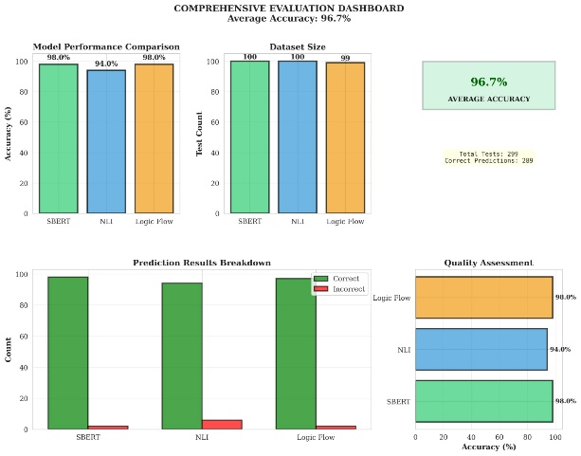
Fig 4:Full model evaluation
“Fig. 5” presents a comprehensive evaluation dashboard summarizing the performance of the proposed system across SBERT, NLI, and Logic Flow models. The model performance comparison indicates that both SBERT and Logic Flow achieve the highest accuracy of 98.0%, while the NLI model attains a slightly lower accuracy of 94.0%. The dataset distribution remains balanced across models, with approximately 100 test samples each, ensuring a fair and unbiased evaluation.
The prediction results breakdown further highlights the robustness of the models, where SBERT and Logic Flow demonstrate a higher number of correct predictions with minimal errors, whereas the NLI model shows comparatively more misclassifications. The quality assessment chart reinforces these findings, illustrating that SBERT and Logic Flow consistently outperform NLI in terms of accuracy.Overall, the system achieves an average accuracy of 96.7% across all models, with a total of 299 test cases and 289 correct predictions. These results demonstrate the effectiveness of combining semantic similarity, logical inference, and structural reasoning to achieve a reliable and high-performing automated evaluation framework.

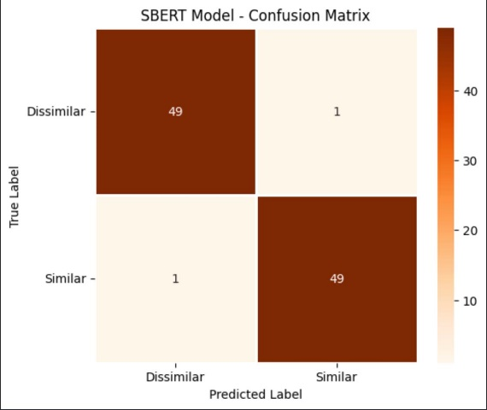
Fig 5:SBERT Confusion Matrix
“Fig. 6” illustrates the confusion matrix of the SBERT model for semantic similarity classification. The model demonstrates strong performance, correctly classifying 49 instances of the dissimilar class and 49 instances of the similar class. Only two misclassifications are observed, with one dissimilar instance incorrectly predicted as similar and one similar instance misclassified as dissimilar. This results in a high overall accuracy of 98.0%, indicating that the SBERT model effectively captures semantic relationships between student and reference answers. The balanced performance across both classes also reflects the model’s robustness and its ability to generalize well without bias toward any specific class.
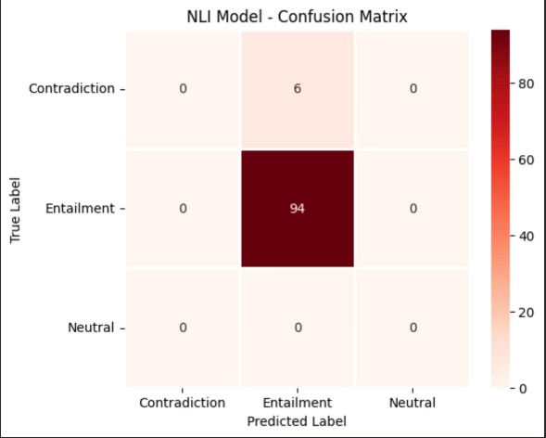
Fig 6: NLI Model-Confusion Matrix
“Fig. 7” presents the confusion matrix of the NLI model used for classifying relationships into contradiction, entailment, and neutral categories. The model demonstrates strong performance in identifying entailment, correctly classifying 94 instances. However, all contradiction instances (6 cases) are misclassified as entailment, and no samples are identified under the neutral class. This results in an overall accuracy of 94.0%, but reveals a bias of the model toward the entailment class. The absence of correct predictions for contradiction and neutral categories indicates that the model struggles to distinguish finer-grained logical relationships, particularly in cases where semantic overlap exists. These observations highlight the need for improved class balancing or enhanced training strategies to better capture diverse inference types.
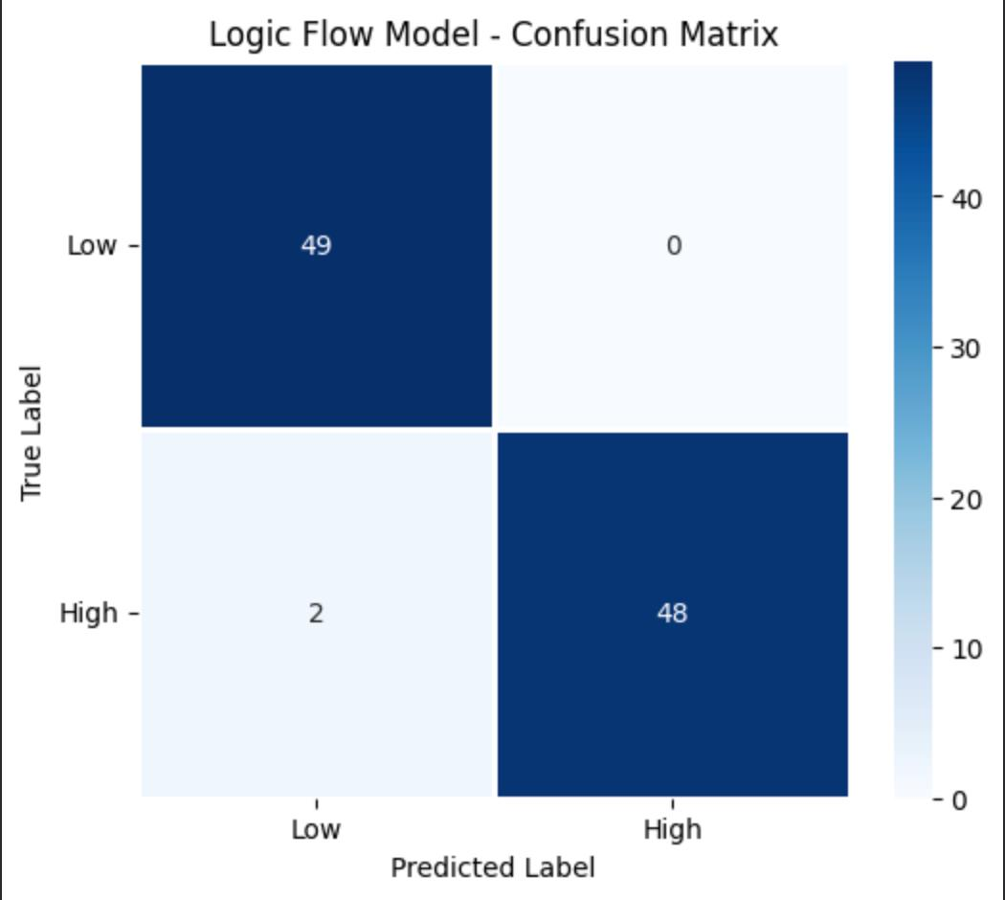
Fig 7:Logic Flow Model Confusion Matrix
“Fig. 8” illustrates the confusion matrix of the Logic Flow model used for classifying answers into low and high quality categories based on structural coherence. The model correctly identifies 49 instances of the low class and 48 instances of the high class, demonstrating strong classification capability. Only two misclassifications are observed, where high-quality responses are incorrectly predicted as low. No low-quality responses are misclassified as high, indicating that the model is conservative in assigning higher quality scores. The overall accuracy of 98.0% reflects the effectiveness of the Logic Flow model in capturing structural and coherence-related features. Additionally, the balanced performance across both classes highlights the robustness of the model in evaluating answer organization and logical progression.

Table 4: Ablation study
Model | Configurtion | Accuracy | Accuracy
SBERT | Full Model(𝜏=0.65) | 98.0% | -
SBERT | Threshold(𝜏=0.50) | 96.0% | -2.0%
SBERT | Threshold(𝜏=0.70) | 94.0% | -4.0%
SBERT | Threshold(𝜏=0.80) | 92.0% | -6.0%
NLI | Full Model | 94.0% | -
NLI | Without Entailment Type | 88.0% | -6.0%
NLI | Without Contradiction Type | 86.0% | -8.0%
NLI | Without Nuetral Type | 84.0% | -10.0%
Logic Flow | Full Model | 98.0% | -
Logic Flow | Without Coherence | 85.0% | -13.0%
Logic Flow | Without Connectors | 88.0% | -10.0%
Logic Flow | Without Structure | 78.0% | -20.0%
Logic Flow | Without Progression | 88.0% | -10.0%

“Table 4” presents the ablation study conducted to analyze the impact of modifying and removing individual components within the SBERT, NLI, and Logic Flow modules. For the SBERT model, varying the similarity threshold demonstrates that the optimal performance is achieved at a threshold of 0.65 with an accuracy of 98.0%. Lowering or increasing the threshold results in a gradual decline in accuracy, indicating the sensitivity of semantic similarity classification to threshold selection.In the NLI model, the full configuration achieves an accuracy of 94.0%.
The removal of individual relation types such as entailment, contradiction, and neutral leads to noticeable performance degradation, with the absence of the neutral class causing the highest drop of 10.0%. This highlights the importance of capturing all logical relationships for effective inference. Similarly, the Logic Flow model achieves 98.0% accuracy in its complete configuration. However, removing key components such as coherence, connectors, structure, and progression significantly reduces performance, with the absence of structural evaluation leading to the largest drop of 20.0%.
This demonstrates that structural reasoning plays a critical role in assessing answer quality. Overall, the ablation results indicate that each component contributes uniquely to the system’s performance. SBERT threshold tuning is crucial for semantic accuracy, NLI relies on balanced logical relationships, and Logic Flow depends heavily on structural coherence, collectively ensuring a robust and comprehensive evaluation framework.
Processing efficiency was evaluated by measuring average evaluation time per answer script. The system demonstrated reasonable processing time, making it suitable for batch evaluation of multiple scripts. While OCR and semantic analysis require computational resources, the system achieved a balance between accuracy and performance.Overall, the evaluation metrics indicate that the proposed system performs effectively in assessing handwritten descriptive answers, offering improved consistency and fairness compared to manual evaluation and keyword-based automated systems.
7.3 Comparison with Existing Systems
A comparative analysis was conducted between the proposed system and existing evaluation approaches to highlight improvements and limitations. Traditional manual evaluation served as the baseline for comparison. Manual grading allows deep contextual understanding but is time-consuming, inconsistent, and subject to evaluator bias.
Keyword-based automated grading systems were also considered. These systems rely on matching predefined keywords or phrases and assigning scores based on word overlap. While computationally efficient, they fail to recognize semantically correct answers expressed using alternative wording. In contrast, the proposed system uses semantic similarity to capture conceptual alignment, resulting in fairer evaluation outcomes.Compared to OCR-only systems, the proposed system integrates semantic analysis to move beyond text extraction. OCR-only systems are limited to digitizing handwritten content and do not perform meaningful evaluation. By combining OCR with transformer-based embeddings, the proposed system provides a complete evaluation pipeline.
When compared to digital-text-based semantic grading systems, the proposed system offers the additional capability of handling handwritten answers. This integration addresses a significant gap in existing research and practice, making the system more applicable to real-world academic environments.
Overall, the proposed system demonstrates clear advantages in fairness, consistency, and scalability when compared to existing approaches.
7.4 Challenges Faced
During the development of the AI-based answer script evaluation system, several technical and practical challenges were encountered. One of the major challenges was handling the variability in handwritten answer scripts. Differences in handwriting styles, character spacing, and writing clarity made it difficult for the OCR system to accurately extract text. Poor image quality due to low resolution, uneven lighting, and noise further affected recognition accuracy.Another significant challenge was dealing with OCR errors. Even after preprocessing, the extracted text often contained misrecognized characters, missing words, or formatting inconsistencies. These errors could negatively impact subsequent NLP processing and semantic similarity computation.
Semantic ambiguity in student answers also posed a challenge. Students may express the same concept using different wording, sentence structures, or levels of detail. Traditional keyword-based approaches are not sufficient to capture such variations, making it difficult to accurately evaluate answers based solely on textual comparison.
Handling context and partial correctness was another issue. Some answers may be partially correct or include both relevant and irrelevant information. Determining the degree of correctness in such cases required more advanced semantic understanding.Additionally, integrating multiple modules such as image preprocessing, OCR, NLP, and semantic analysis into a single system was challenging. Ensuring smooth data flow, proper communication between modules, and efficient processing required careful system design.
User acceptance was also a concern. Educators may be hesitant to rely on automated systems for evaluation due to concerns about accuracy, transparency, and trustworthiness of results.
7.5 Solutions Implemented
To address the challenges related to image quality and handwriting variability, image preprocessing techniques such as grayscale conversion, noise reduction, thresholding, and skew correction were implemented. These techniques significantly improved the clarity of input images and enhanced OCR performance.OCR-related issues were mitigated by using a reliable OCR framework and refining preprocessing steps. Additionally, the system was designed to pass OCR output through a text preprocessing stage, where errors were minimized using normalization techniques such as tokenization, stopword removal, and lemmatization.
To handle semantic ambiguity, transformer-based models such as sentence embeddings were used instead of traditional keyword matching. These models capture contextual meaning and enable the system to evaluate answers based on conceptual similarity rather than exact wording.Partial correctness was addressed by using similarity scores instead of binary evaluation. The scoring mechanism allows answers to be graded on a continuous scale, reflecting varying degrees of correctness.For system integration challenges, a modular architecture was adopted. Each component of the system was developed independently with well-defined interfaces, ensuring smooth data flow and easier debugging.
To improve user trust and acceptance, the system provides transparent outputs, including similarity scores and evaluation breakdowns. This allows educators to understand how the final score is generated and use the system as a supportive tool rather than a replacement.
7.6 Discussion of Results
The experimental results demonstrate that the proposed AI-based automated evaluation system effectively evaluates handwritten descriptive answers based on semantic meaning. High similarity scores were consistently observed for conceptually correct answers, even when expressed using varied vocabulary and sentence structures. This confirms the effectiveness of transformer-based semantic embeddings in capturing contextual meaning.
OCR performance emerged as a critical factor influencing evaluation accuracy. While preprocessing improved recognition quality, OCR errors still affected semantic similarity in cases of extremely poor handwriting. This highlights the importance of further improvements in handwriting recognition and error correction techniques.
The system showed strong alignment with human evaluation for well-written and moderately legible answers. Minor discrepancies were observed for partially correct answers, where semantic similarity scores reflected partial conceptual alignment. These results suggest that the system can assist educators in preliminary evaluation while leaving nuanced judgment to human evaluators.
Another important observation is the system’s ability to reduce evaluation time significantly. Automated processing enables rapid assessment of multiple scripts, making the system suitable for large-scale academic use. The consistent scoring behavior further enhances trust and reliability.The discussion also highlights limitations such as handling of diagrams, equations, and highly ambiguous answers. Addressing these limitations presents opportunities for future enhancement.
7.7 Limitations and Observations
Despite its strengths, the proposed system has certain limitations. OCR accuracy remains a challenge for poorly written scripts, which may affect semantic evaluation. Additionally, the system currently focuses on textual answers and does not evaluate diagrams or mathematical expressions.Semantic similarity models may struggle with domain-specific terminology not well represented in training data. Interpretability of similarity scores may also require further enhancement to improve user trust.These observations provide valuable insights for refining the system and guiding future research directions.

CHAPTER VIII
CONCLUSION AND FUTURE SCOPE
8.1 Conclusion
This project presented the design, development, and evaluation of an AI-based automated evaluation system for handwritten descriptive answer scripts using Optical Character Recognition and semantic similarity analysis. The primary motivation behind this work was to address the limitations of traditional manual evaluation and keyword-based automated grading systems, which are often time-consuming, inconsistent, and unable to capture conceptual correctness effectively.
Throughout the project, a comprehensive approach was adopted to transform handwritten answer scripts into meaningful evaluation outcomes. The system integrates multiple technologies, including image preprocessing, OCR, Natural Language Processing, and transformer-based semantic embedding models, to perform meaning-based grading. By following a modular and layered design, the system ensures robustness, scalability, and ease of maintenance.
The implementation demonstrated that preprocessing techniques significantly enhance OCR performance, enabling reliable extraction of handwritten text even under varying handwriting styles and image quality conditions. Although OCR errors cannot be entirely eliminated, the preprocessing pipeline reduces noise and improves text clarity, forming a strong foundation for downstream semantic analysis.
The use of semantic similarity models represents a key contribution of this project. Unlike traditional keyword-based approaches, the proposed system evaluates answers based on conceptual alignment with reference answers. Experimental results showed strong correlation between semantic similarity scores and human evaluation for well-written and moderately legible answers. This confirms that transformer-based sentence embeddings effectively capture contextual meaning and enable fair evaluation even when students use different wording to express correct ideas.
Another significant outcome of this project is the improvement in evaluation consistency. Automated scoring eliminates variations caused by evaluator fatigue, bias, or subjective interpretation, ensuring uniform assessment standards across multiple evaluations. Additionally, the system reduces evaluation time considerably, making it suitable for large-scale academic assessments where timely feedback is essential.
From an academic perspective, the project demonstrates the practical applicability of Artificial Intelligence in education. The system is designed as an assistive tool that supports educators rather than replacing human judgment. By providing objective similarity scores and interpretable outputs, the system enhances decision-making while preserving the educator’s role in final evaluation.
Despite its strengths, the project also highlighted certain limitations, such as sensitivity to poor handwriting quality and inability to evaluate non-textual content. These limitations are acknowledged and serve as motivation for further research and enhancement.
In conclusion, the proposed automated evaluation system successfully addresses key challenges in handwritten descriptive answer evaluation by combining OCR and semantic similarity techniques. The project contributes a practical, scalable, and fair assessment solution that aligns with modern educational needs and demonstrates the potential of AI-driven tools in improving academic assessment processes.
8.2 Future Scope
While the proposed system achieves its primary objectives, several opportunities exist for extending and enhancing its capabilities. One major area for future work is improving handwriting recognition accuracy. Incorporating more advanced handwriting-specific OCR models or training custom recognition models using domain-specific datasets could further reduce recognition errors, especially for poorly written scripts.
Another important direction for future enhancement is the evaluation of non-textual content. Many academic assessments include diagrams, flowcharts, mathematical expressions, and equations. Extending the system to recognize and evaluate such content would significantly broaden its applicability. Integrating mathematical expression recognition and diagram interpretation techniques could enable more comprehensive automated evaluation.
Multilingual support represents another promising area for future development. Currently, the system focuses on answers written in English. Extending support to multiple languages would make the system suitable for diverse educational environments. This would require multilingual OCR models and language-specific semantic embedding techniques capable of handling linguistic diversity.
The interpretability of evaluation results can also be enhanced in future versions. While similarity scores provide objective evaluation, educators may benefit from more detailed explanations of how scores are derived. Incorporating explainable AI techniques could help generate feedback highlighting missing concepts or partially correct sections, increasing transparency and trust in automated evaluation.Integration with Learning Management Systems (LMS) is another valuable extension. Seamless integration would allow automatic evaluation of assignments and examinations within existing digital education platforms. This would streamline assessment workflows and provide real-time feedback to students.
From a scalability perspective, future work could focus on optimizing system performance for large-scale deployment. Techniques such as parallel processing, cloud-based deployment, and model optimization could further improve efficiency and enable handling of massive datasets during peak examination periods.
Ethical considerations also present an important area for future exploration. Ensuring fairness, avoiding bias, and maintaining data privacy are critical when deploying AI-based assessment systems. Future research can focus on developing ethical guidelines and validation frameworks to ensure responsible use of automated evaluation technologies.
In summary, the future scope of this project is extensive. By addressing current limitations and exploring new research directions, the system can evolve into a comprehensive, intelligent assessment platform capable of supporting diverse academic evaluation needs. These enhancements would further strengthen the role of AI in education and contribute to more efficient, fair, and scalable assessment practices.
8.3 Project Contribution and Impact
The proposed AI-based answer script evaluation system makes several significant contributions to the field of educational technology by integrating advanced Artificial Intelligence and Natural Language Processing techniques into the assessment process. One of the primary contributions of this project is the development of an automated evaluation framework capable of analyzing descriptive answers based on semantic meaning rather than simple keyword matching. This approach enables more accurate and meaningful assessment of student responses.Another key contribution is the integration of Optical Character Recognition (OCR) with semantic analysis, allowing the system to process handwritten answer scripts and convert them into machine-readable text. This bridges the gap between traditional handwritten examinations and modern digital evaluation systems. The implementation of image preprocessing techniques further enhances OCR performance, ensuring reliable text extraction from varied input conditions.
The project also introduces the use of transformer-based models, such as sentence embeddings, for computing semantic similarity between student answers and reference answers. This enables the system to understand contextual meaning and evaluate answers even when different wording is used. The incorporation of cosine similarity as a scoring mechanism ensures efficient and scalable evaluation.Additionally, the system is designed with a modular architecture, allowing each component—image preprocessing, OCR, NLP processing, and semantic analysis—to function independently. This modularity improves maintainability and allows future enhancements, such as upgrading OCR models or incorporating multilingual support, without affecting the overall system.
The project also contributes by providing an intuitive and user-friendly interface that enables educators to easily upload answer scripts, initiate evaluation, and interpret results. By presenting evaluation outputs in a transparent and understandable manner, the system supports informed decision-making and enhances user trust.The implementation of the proposed system has a significant impact on the education sector by transforming the traditional evaluation process into a more efficient, accurate, and scalable solution. One of the major impacts is the reduction in manual effort required for grading descriptive answer scripts. By automating the evaluation process, the system saves time for educators and allows them to focus more on teaching and student engagement.
The system also improves the consistency and fairness of evaluation by minimizing human bias and subjectivity. Automated scoring ensures that all student answers are evaluated using the same criteria, leading to more reliable and standardized assessment outcomes.
Another important impact is the ability to provide faster feedback to students. Quick evaluation enables students to understand their performance in a timely manner, which can enhance learning outcomes and encourage continuous improvement. This is particularly beneficial in large-scale examinations where manual evaluation can be time-consuming.The project also supports digital transformation in education by enabling paper-based answer scripts to be processed and evaluated digitally. This reduces dependency on manual processes and contributes to environmentally sustainable practices by minimizing paper handling and storage requirements.Furthermore, the system has the potential to be extended to various educational applications, including online assessments, competitive examinations, and training platforms. Its scalability and adaptability make it suitable for diverse academic environments.
Finally, the project promotes the adoption of AI-driven solutions in education, demonstrating how emerging technologies can be effectively utilized to address real-world challenges. By combining accuracy, efficiency, and scalability, the proposed system contributes to the advancement of intelligent educational systems and paves the way for future innovations.

REFERENCES
- A.M. Abd El-Haleem, M. A. Eltahir, and H. A. ElSayed, 2022, “A generic AI-based technique for assessing student performance in conducting online virtual and remote controlled laboratories,” IEEE Access, vol. 10, pp. 89012–89027.
- M. A. Ahad, E. Al-Shara, and S. Hameed, 2022, “A systematic review of deep learning based online exam proctoring systems for abnormal student behaviour detection,” International Journal of Scientific Research in Science, Engineering and Technology, vol. 9, no. 2, pp. 120–135.
- Y. Attali and J. Burstein, 2006, “Automated essay scoring with e-rater V.2,” The Journal of Technology, Learning and Assessment, vol. 4, no. 3, pp. 1–30.
- J. Cain, M. Meldrum, F. Romano, and A. Persky, 2022, “Deficiencies of traditional grading systems and recommendations for the future,” American Journal of Pharmaceutical Education, vol. 86, no. 4, art. 8765.
- J. Devlin, M. W. Chang, K. Lee, and K. Toutanova, 2019, “BERT: Pre-training of deep bidirectional transformers for language understanding,” in Proc. North American Chapter of the Association for Computational Linguistics (NAACL-HLT), Minneapolis, MN, USA, pp. 4171–4186.
- P. W. Foltz, D. Laham, and T. K. Landauer, 1999, “The Intelligent Essay Assessor: Applications to educational technology,” Interactive Multimedia Electronic Journal of Computer-Enhanced Learning, vol. 1, no. 2.
- A.Jonall, 2024, “Artificial intelligence in academic grading,” International Journal of Educational Technology in Higher Education, vol. 21, art. 18.
- G. Kortemeyer, 2023, “Toward AI grading of student problem solutions in introductory physics: A feasibility study,” Physical Review Physics Education Research, vol. 19, no. 1, art. 010128.
- M. Li, L. Xu, L. Liu, and D. Wang, 2021, “TrOCR: Transformer-based optical character recognition with pre-trained models,” in Proc. IEEE/CVF International Conference on Computer Vision (ICCV), Montreal, Canada, pp. 1412–1421.
- J. Müller et al., 2025, “An evaluation of AI-based grading of multiple choice assessments,” Education and Information Technologies, vol. 30, art. 102345.
- T. H. Nguyen et al., 2025, “Application of AI in grading new question types in the 2025 Vietnamese high school graduation exam,” European Journal of Educational Studies, vol. 12, no. 3, pp. 45–60.
- E. B. Page, 1966, “The imminence of grading essays by computer,” Phi Delta Kappan, vol. 47, no. 5, pp. 238–243.
- D. Ramesh and S. Ramachandram, 2021, “Automated essay scoring systems: A systematic literature review,” Artificial Intelligence Review, vol. 55, no. 3, pp. 2495–2527.
- R. K. Sharma and P. Mehta, 2025, “Improving interaction and assessment in hybrid educational environments: An integrated approach in Microsoft Teams with the use of AI techniques,” Education and Information Technologies, vol. 30, art. 101982.
- M. D. Shermis and J. Burstein, 2013, Handbook of Automated Essay Evaluation: Current Applications and New Directions. New York, NY, USA: Routledge.
- M. A. Sultan, S. Bethard, and T. Sumner, 2016, “DLS@CU: Sentence similarity from word alignment and semantic vector composition,” in Proc. 10th International Workshop on Semantic Evaluation (SemEval), San Diego, CA, USA, pp. 356–361.
- M. A. Yakubu, A. Hassan, and S. Abdullahi, 2024, “Application of artificial intelligence (AI) for automated essay grading in Nigerian schools,” Indonesian Journal on Education, vol. 8, no. 1, pp. 22–35.
- Y. Zhang, R. Shah, and M. Chi, 2016, “Deep learning + student modeling + automated essay scoring = automatic short answer grading system,” in Proc. 9th International Conference on Educational Data Mining (EDM), Raleigh, NC, USA, pp. 2–9.


INTERNAL QUALITY ASSURANCE CELL
PROJECT AUDIT REPORT

This is to certify that the project work entitled “AI-BASED AUTOMATED EVALUATION OFHANDWRITTEN ANSWER SCRIPTS USING OCR AND SEMANTIC SIMILARITY” categorized as an internal project done by Pavithira.S, Sabana Fathima.A, Pooja Sri.M.G, Nasreen Sajila.U.M of the Department of Computer Science and Engineering, under the guidance of Aravind Chandran during the Even semester of the academic year 2025 - 2026 are as per the quality guidelines specified by IQAC.

Quality Grade

Deputy Dean (IQAC)

Administrative Quality Assurance Dean (IQAC)

